**Part 1: Navigation Bar with Routing**

**Aim:**

To implement a **navigation bar** in ReactJS that allows smooth routing between pages like Home, Products, Cart, Checkout, and Profile using **React Router**.

**Theory**

In modern web development, websites are designed as **Single Page Applications (SPAs)**, where all navigation happens dynamically without reloading the entire page. **React Router** is a powerful library in ReactJS that allows developers to implement page navigation within a single application efficiently.

React Router enables **client-side routing**, meaning navigation between pages happens instantly by switching components instead of reloading from the server. This ensures a **faster and smoother user experience** — crucial for e-commerce and interactive web apps like the one we’re developing.

The **Navigation Bar (Navbar)** acts as the main interface element that allows users to move between pages such as *Home*, *Products*, *Cart*, *Checkout*, and *Profile*. Using React Router, each of these pages is represented as a **Route**, and the Navbar links correspond to different **paths (URLs)**.

React Router uses components like:

* <BrowserRouter> – Wraps the entire app for routing support.
* <Routes> and <Route> – Define each route (path) and the component to render.
* <Link> or <NavLink> – Create navigation links that change the route without reloading the page.

This routing mechanism helps maintain the application’s state, especially the cart or logged-in user details, while navigating between pages.

The main advantages of using React Router include:

1. **Seamless User Experience:** Navigation feels instant and app-like.
2. **Preserved State:** Data remains intact across different views.
3. **Dynamic Routing:** Routes can change based on logic (e.g., authenticated users).
4. **Cleaner Code:** Routes are organized neatly inside a routing structure.

In this project, the **Navigation Bar** provides easy access to different sections. It improves usability and enhances the aesthetic appeal by keeping navigation consistent across the site. The Navbar will remain visible at the top, even as users switch between pages — giving a professional and cohesive layout

The navigation bar is a key element in any website, serving as the main interface through which users access different sections of the application. In a React application using React Router, the Navbar typically contains several NavLinks corresponding to available routes such as Home, Products, Cart, Checkout, and Profile.

A well-designed Navbar stays consistent across all pages, offering users a unified and intuitive experience. It often remains fixed at the top of the page, ensuring easy access to navigation options even while scrolling. When combined with React Router, this allows seamless, instant navigation between pages without losing the current application state.

For example, in an e-commerce SPA, a user might browse products, add items to the cart, and move to the checkout page—all without any page reload. React Router ensures that the cart’s state remains preserved during these actions, maintaining continuity in user experience and reducing frustration.

Thus, the Navbar not only improves usability but also reinforces the professional appeal of the site. It contributes significantly to both user satisfaction and visual consistency.

React Router is a powerful library that manages navigation and routing within React applications. It allows developers to define multiple routes within a single-page structure, enabling users to switch between different components (for example, Home, Products, Cart, Checkout, and Profile) without triggering a full-page reload.

When React Router is used, navigation becomes entirely client-side. Instead of requesting a new page from the server, it merely updates the browser’s history and renders the appropriate component instantly. This ensures that the user experience remains smooth, responsive, and consistent with the expectations of a modern web application.

**Key Components of React Router**

React Router relies on several core components to implement routing functionality efficiently:

1. **BrowserRouter**  
   This acts as the container that wraps the entire React application. It enables the browser’s History API, allowing the app to synchronize the UI with the URL.
2. **Routes and Route**  
   These components define the set of navigable paths and specify which component should be displayed when a certain path is active. For example, a Route with the path “/products” might render a ProductList component.
3. **Link and NavLink**  
   These components replace traditional HTML anchor tags. They update the route dynamically without reloading the page. NavLink is often used for navigation bars because it provides additional styling options, such as highlighting the active link.

**Code:**

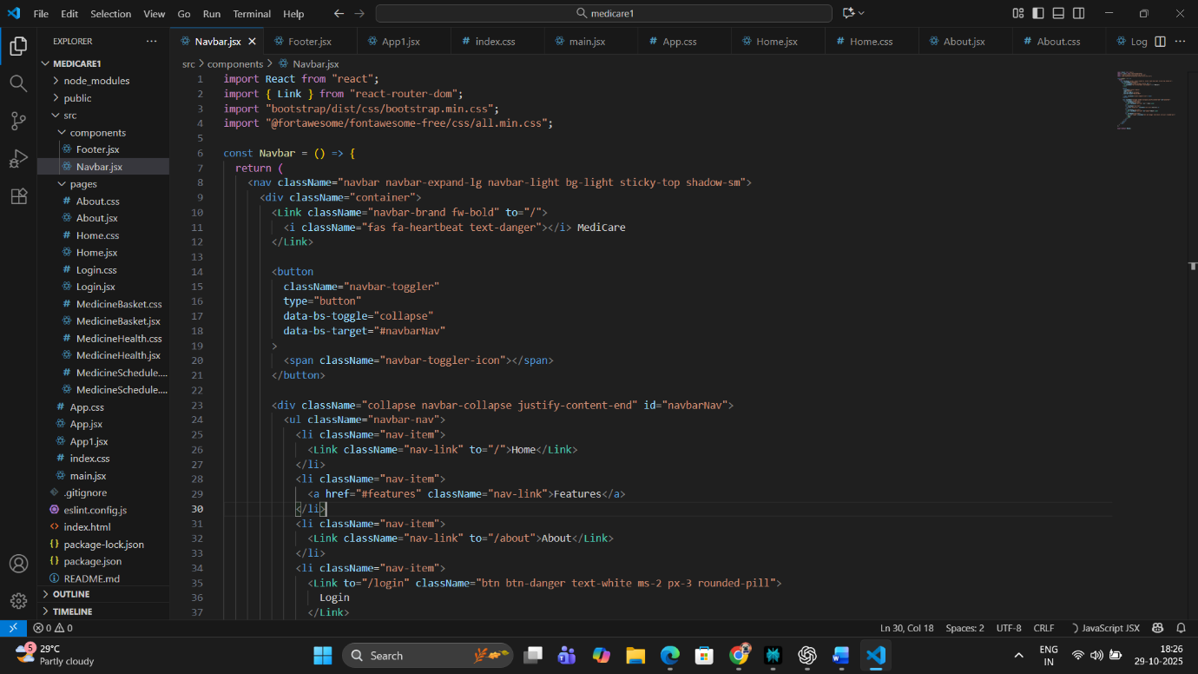

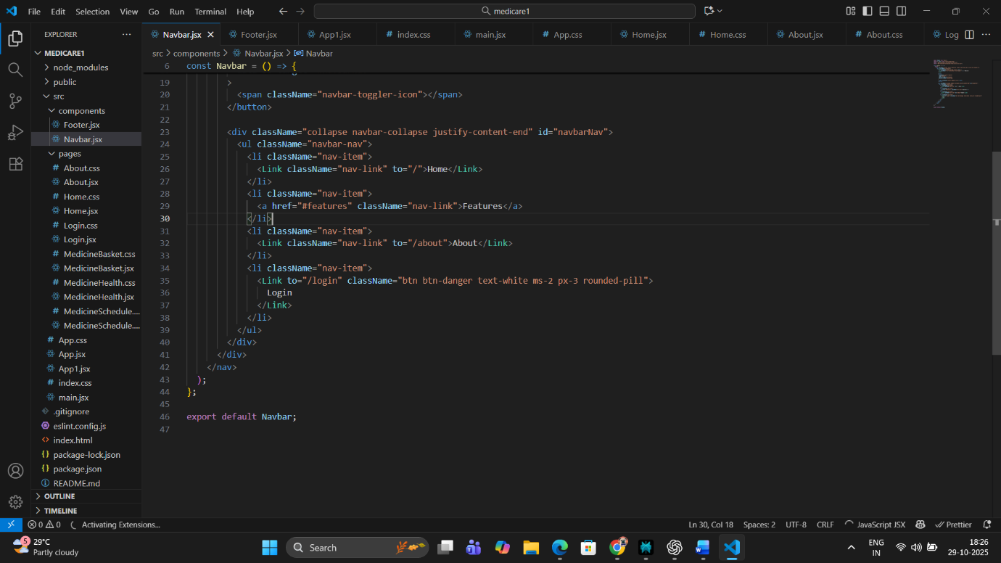

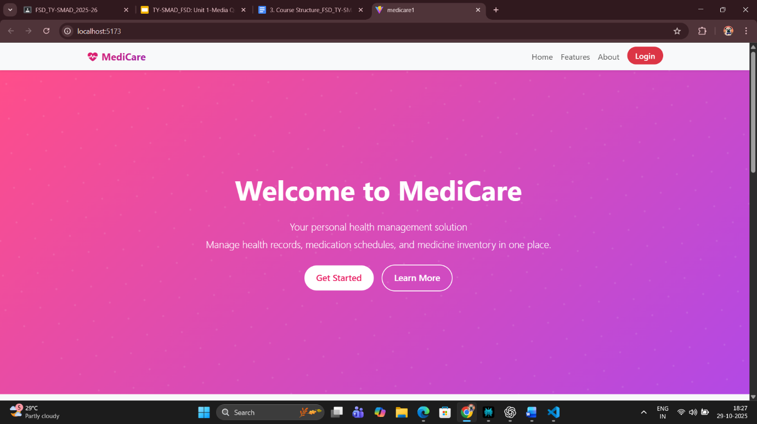

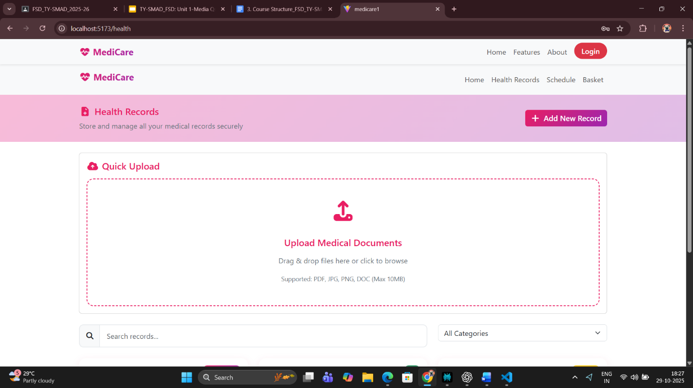

**Output Preview:**  
A purple navigation bar with white text links for *Home*, *Products*, *Cart*, *Checkout*, and *Profile*. Clicking a link changes the route instantly without reloading the page.

**Conclusion:**

In this module, we learned how to use **React Router** to create seamless navigation between different sections of a web application. The **Navigation Bar** enhances user accessibility and provides a structured layout, ensuring users can move smoothly between Home, Products, Cart, Checkout, and Profile without losing data or refreshing

**Part 2 – Home Page:**

**Aim:**

To design and develop a visually appealing, interactive, and responsive Home Page for the *MediCare* ReactJS web application that acts as a central hub for users to manage their health-related activities. The page should welcome users, highlight the main features — such as health record storage, medication scheduling, and medicine tracking — and provide smooth navigation using React components and modern responsive design principles.

**Theory:**

The Home Page is the most essential and user-facing component of any web application. In *MediCare*, the home page serves as a digital entry point where users are greeted with a friendly interface that promotes trust and engagement while maintaining simplicity. This React-based design ensures that users immediately understand the purpose of the platform — to manage health records, set medicine reminders, and track medication inventory efficiently.

Built using ReactJS functional components, the MediCare Home Page combines interactivity, reusability, and modular design. The navigation bar at the top, implemented as a reusable React component, provides seamless routing to other sections such as *Home, Features, About,* and *Login*. This is achieved through React Router DOM, which allows smooth navigation between pages without reloading the browser — one of the key strengths of React Single Page Applications (SPA).

The hero section, featuring a gradient background and central welcome text “Welcome to MediCare,” has been carefully designed to immediately draw user attention. The use of Bootstrap-inspired classes or CSS Flexbox/Grid styling ensures proper alignment and spacing across screen sizes. The inclusion of prominent buttons such as “Get Started” and “Learn More” encourages user engagement and creates a natural call-to-action, an essential design principle in UI/UX.

Below the hero section, the *Key Features* area highlights the three main functions of MediCare — *Health Records, Medication Schedule, and Medicine Basket.* Each feature is presented in a card layout with attractive icons and hover effects, symbolizing both usability and visual appeal. These cards help users quickly grasp the platform’s core utilities without needing to read lengthy descriptions. Each card is structured using React JSX elements, allowing easy modification or dynamic data integration in the future.

An important part of the design is responsiveness, achieved using CSS media queries and Flexbox alignment utilities. The MediCare home page automatically adjusts its layout and font sizes based on the screen resolution, providing a consistent experience on laptops, tablets, and mobile phones. For example, the feature cards realign into a vertical stack on smaller devices while maintaining readability and balance.

The statistics section — showing *10K+ Happy Users, 50K+ Health Records,* and *25K+ Medications Tracked* — adds a sense of reliability and growth to the application. This section demonstrates how textual content and numerical highlights can enhance user trust through visualization of community impact. The figures may currently be static but can be dynamically fetched from a backend or JSON file in later development stages.

Finally, the footer section (“© 2025 MediCare | Made by Riya Gandhi”) brings professionalism and completion to the page. It also aligns with accessibility principles by maintaining proper contrast, typography, and minimalism.

From a technical perspective, the MediCare Home Page uses React’s component-based architecture to ensure that every section (Navbar, Hero, Features, Stats, Footer) is reusable and independently maintainable. The state management for interactive elements, such as buttons or potential animations, can be handled via React Hooks (like useState or useEffect). This modular structure allows future scalability — new components such as user testimonials or health tips can be added without disrupting existing design.

The home page also follows the principles of modern responsive web design, including:

* Mobile-first approach with adaptive layouts,
* Clean typography and accessible color contrast,
* Smooth transitions for better visual experience, and
* Lightweight, optimized assets for fast loading time.

Overall, the MediCare Home Page in ReactJS effectively combines technology and healthcare awareness. It focuses on providing a user-friendly digital health assistant experience — ensuring that patients, doctors, or caregivers can easily begin their journey with confidence and convenience.

The MediCare Home Page operates within a **Single Page Application (SPA)** structure enabled by React Router DOM. Traditional websites reload the page every time a link is clicked; however, in SPAs, React renders new components dynamically within the same page, ensuring uninterrupted user experience. This results in faster transitions and a **mobile-app-like feel**, which is a significant factor in modern web usability.

The routing system may include paths like /home, /features, /about, and /login. These routes map to respective React components, which are rendered conditionally based on user navigation. This offers:

* Quicker load times since assets are preloaded.
* Reduced network usage through component reusability.
* Enhanced user retention driven by smooth, real-time page transitions.

Overall, the implementation of SPA architecture in MediCare reflects an understanding of the shift toward fluid, application-like web experiences.

**Code:**

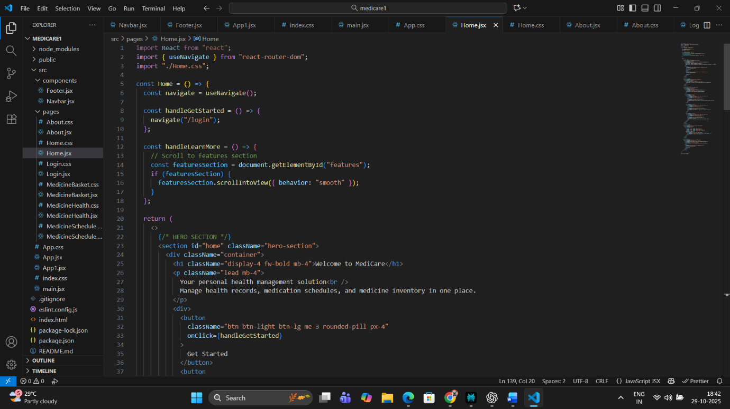

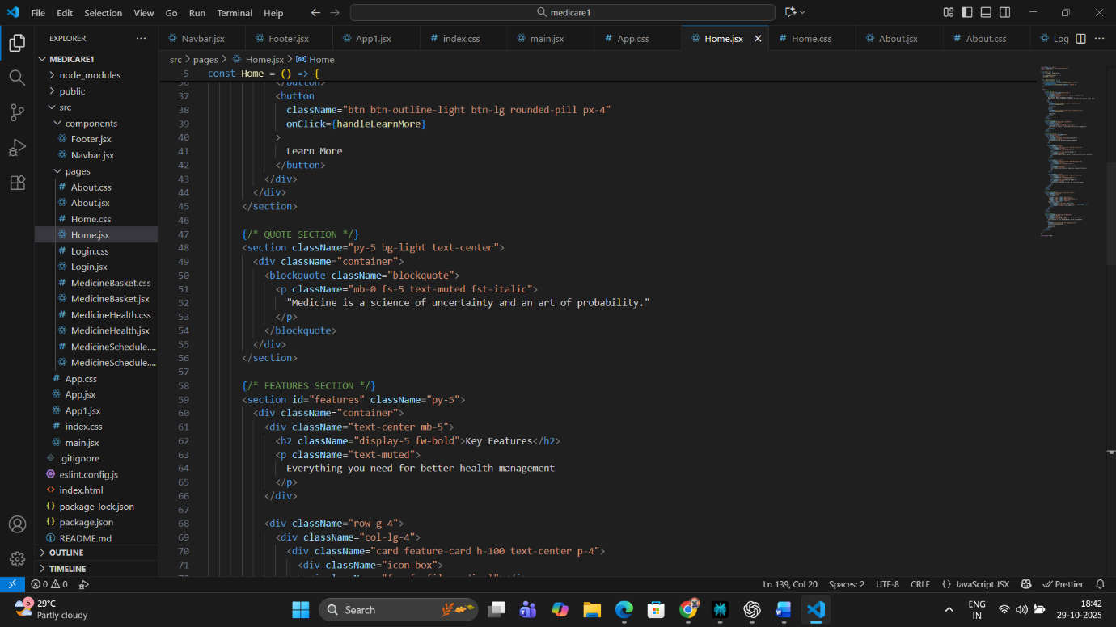

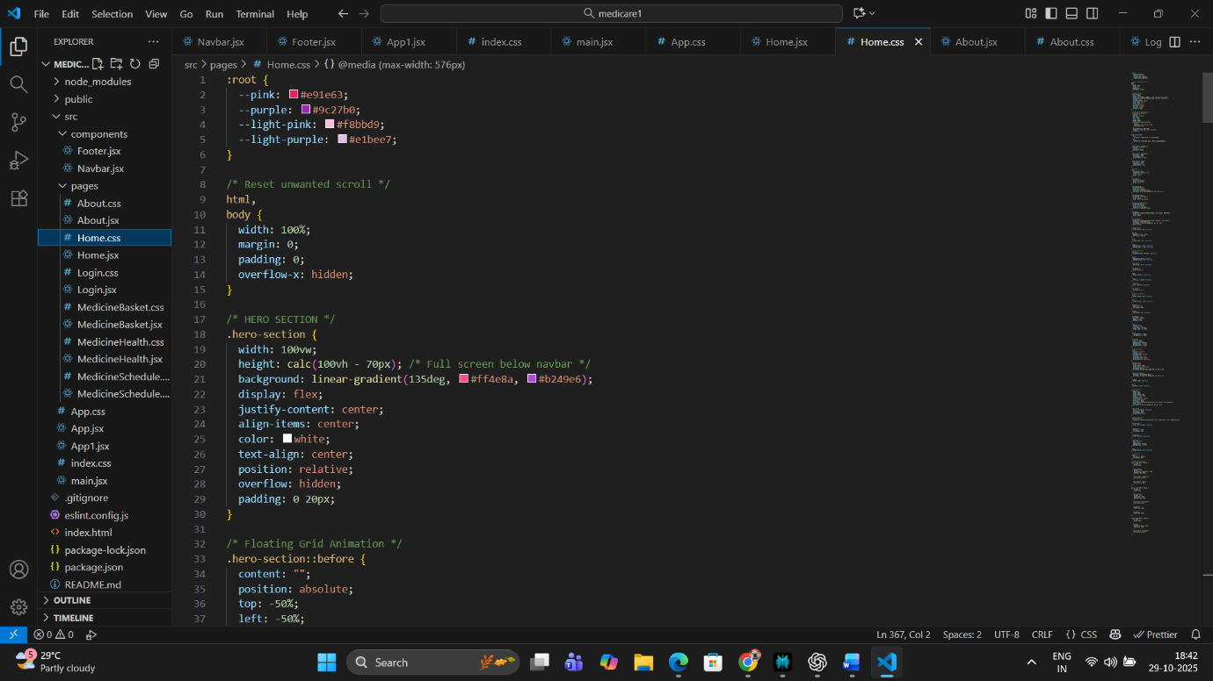

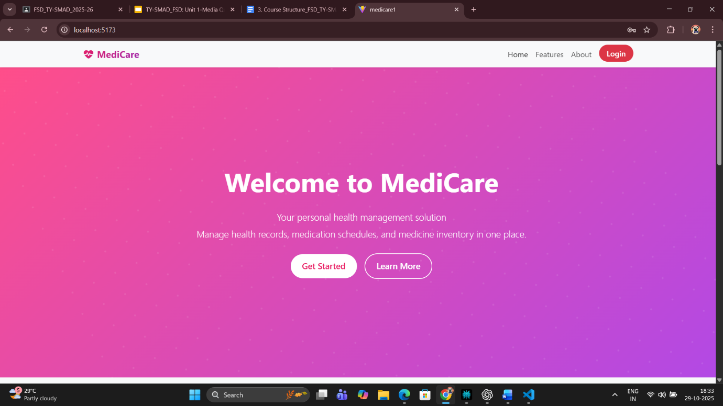

**Conclusion:**

The development of the MediCare Home Page using ReactJS successfully demonstrates how modern frontend technologies can revolutionize user interaction in the healthcare domain. The page not only serves as a visual gateway but also reinforces the application’s purpose — empowering users to manage their medicines, health records, and reminders efficiently.

By implementing a responsive design with modular React components, the system achieves both flexibility and maintainability. The inclusion of feature cards, clean typography, and interactive buttons enhances user engagement while maintaining simplicity. The page layout effectively conveys trust and clarity, which are vital for any health management platform.

Furthermore, the home page design adheres to user-centric and accessibility principles, ensuring that it remains intuitive for users of all ages and technical backgrounds. Its responsive behavior across devices ensures seamless accessibility, aligning with the global push toward digital healthcare inclusion.

In conclusion, the MediCare Home Page stands as a strong foundation for the complete ReactJS-based healthcare web application. It merges creativity, usability, and functionality into a cohesive experience, embodying the core idea that technology can simplify and improve personal health management. This module lays the groundwork for deeper integrations such as dynamic data fetching, real-time medicine tracking, and user dashboards — all built upon the solid base of this well-structured and interactive React home interface.

**Part 3 – Product Listing Page (Medicine List & Details Display)**

**Aim:**

To design and implement a **Product Listing Page** in the MediScan web application that displays a collection of medicines with essential details such as name, dosage, description, and purpose. The page should allow users to view available medicines, understand their usage, and interact with the data dynamically using ReactJS state and props.

**Theory :**

In the modern healthcare ecosystem, digital applications play an essential role in organizing, monitoring, and simplifying the management of medical information. Among the different modules of any healthcare-based software, the Product Listing Page (PLP) — also known as the Medicine List Page — is one of the most crucial components.

In the MediScan project, this page acts as a central repository displaying detailed information about each medicine. It is where patients, users, or healthcare professionals can view all available medicines in a structured and accessible format.

The purpose of this module is to ensure that medicine data is not only visible but informative, organized, and reliable. The design of this page aims to help users identify the right medicine by category, usage, or purpose — directly contributing to health awareness and safety.

MediScan’s Medicine Listing Page is developed using ReactJS, one of the most popular JavaScript libraries for building modern, responsive web applications. React’s component-based design allows the page to dynamically render multiple medicine items efficiently, ensuring the interface remains consistent, scalable, and maintainable.

A **Product Listing Page (PLP)**, often referred to as a **Medicine List Page** in healthcare-based applications, plays an essential role in organizing and displaying relevant data to the user. In the **MediScan** project, this page serves as the central directory where all medicines uploaded by the admin or stored in local storage are displayed in a structured, accessible, and user-friendly way.

From a technical perspective, ReactJS allows the dynamic rendering of lists using the **.map()** function. Instead of writing static HTML for every medicine, React’s component-based architecture helps to repeat a layout template for multiple medicines efficiently. This improves scalability — for instance, if the number of medicines grows from 5 to 500, the same component logic handles the display automatically.

The medicine listing typically includes attributes such as:

* **Medicine Name**
* **Category (Tablet/Syrup/Injection)**
* **Dosage Information**
* **Purpose/Uses**
* **Storage Instructions**

These can be displayed in **cards or table layouts** depending on the interface preference. Each item can be represented by a separate **MedicineCard component**, making the UI modular and reusable.

ReactJS promotes **reusability and maintainability**, which is particularly useful in projects like MediScan, where each medicine has similar information. This ensures consistency and reduces code redundancy. Additionally, integrating **local storage** helps retain the data between sessions without needing a backend — making it perfect for lightweight student projects.

From a design point of view, the Medicine Listing Page must focus on **clarity, color balance, and legibility**. Using color themes consistent with the MediScan identity (Purple, White, and Black) gives the page a professional and medical-grade appearance. Shadowed cards and hover effects increase interactivity, helping users distinguish different medicine records visually.

In the healthcare context, such a page is more than just a list — it’s a **data reference platform** for patients to track and remember their medicines. With the addition of future enhancements like dosage reminders or stock alerts, this page can act as the foundation for automated health record management.

Therefore, this module demonstrates the combined power of **React’s component-driven development** and the **usability principles of health informatics**, ensuring users get both functionality and simplicity in one interface.

**Code:**

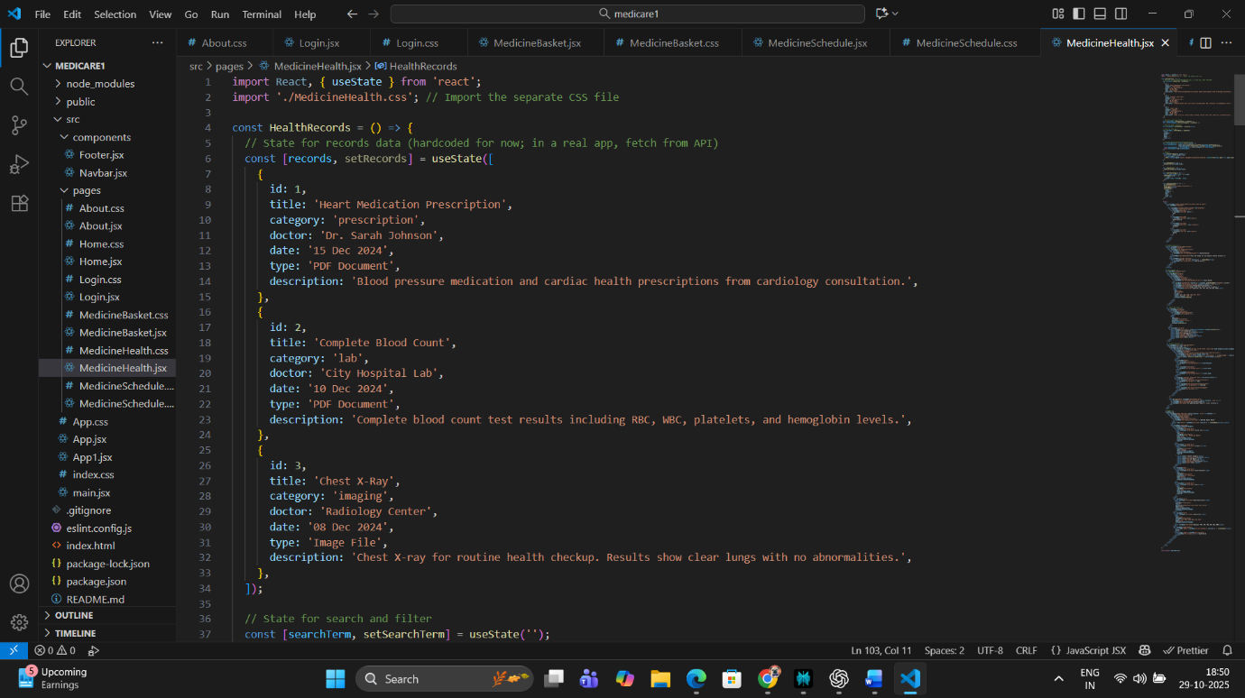

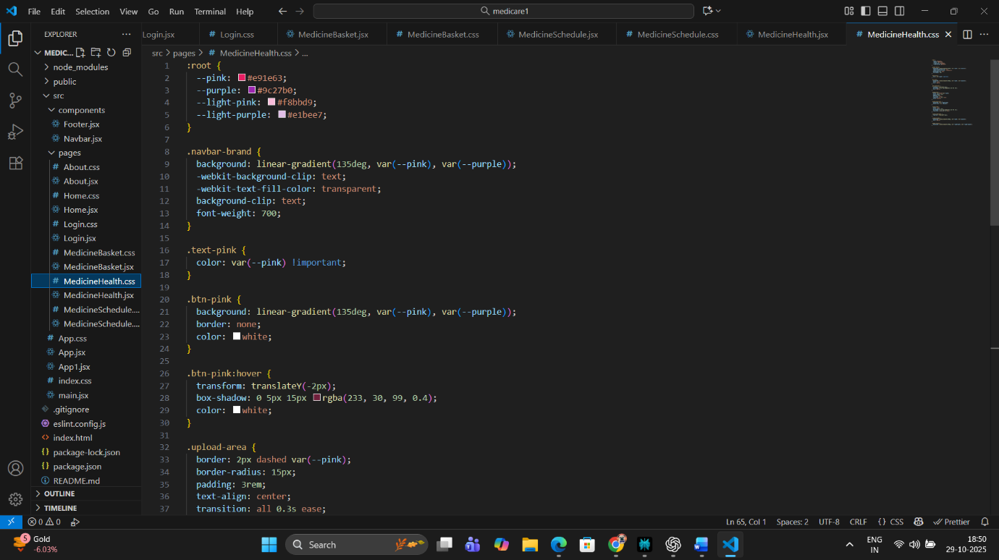

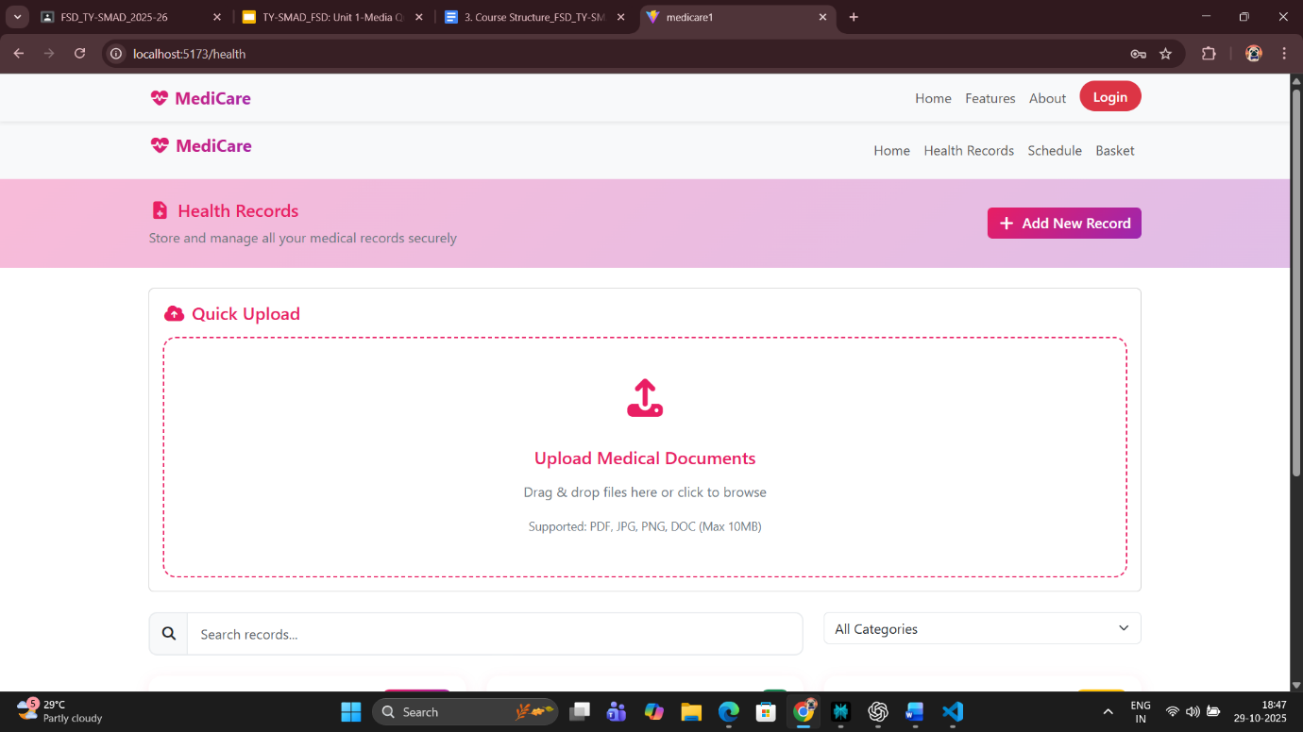

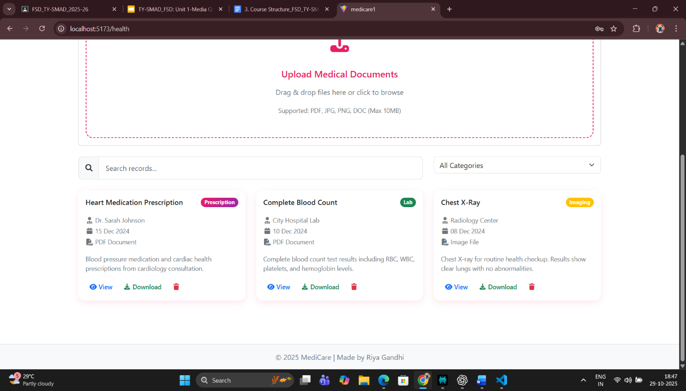

**Explanation:**

* useEffect() is used to load medicine data when the component mounts.
* The medicines are stored in **localStorage**, simulating real database persistence.
* React dynamically renders each medicine as a separate card using .map().
* If no data exists, a fallback message is displayed.

**Conclusion:**

The **Medicine Listing Page** in MediScan marks a vital transition from static interfaces to interactive and data-driven design. By using React’s useState and useEffect hooks, the module allows dynamic rendering of medicine data from local storage, reflecting real-world data management scenarios.

This component highlights how **front-end data visualization** can make health information more accessible and meaningful. Rather than overwhelming the user with plain text, each medicine is shown in a clean, structured card layout — offering readability and professionalism. The use of React’s .map() ensures scalability and efficiency, making it easy to extend the dataset without additional coding effort.

From a technical learning standpoint, this module demonstrates key ReactJS principles like:

* State management using hooks
* Local storage integration
* Conditional rendering
* Component reusability and responsiveness

In the real world, such an approach could power the backend of electronic health records (EHR) systems or mobile medicine tracking apps.

In conclusion, the Medicine Listing Page not only strengthens the **functional structure of MediScan** but also reinforces the idea that good UI design directly improves **user health literacy and engagement**. This combination of front-end interactivity and health data organization makes it a significant module in the overall project.

**Part 4 – Medicine Reminder & Dose Tracker Page**

**Aim:**

To develop a **Medicine Reminder and Dose Tracker** page in the MediScan ReactJS web application that enables users to schedule their medicines, set reminders, and track the status of doses taken or missed. The objective is to simulate smart medicine management using ReactJS state, local storage, and event-driven updates.

**Theory :**

The **Medicine Reminder and Dose Tracker** is a crucial part of MediScan, designed to help users take medicines on time and maintain adherence to prescribed treatments. In modern healthcare, **medication adherence** — the extent to which patients take medicines as prescribed — is a significant concern. Studies show that nearly 50% of patients forget or skip doses, leading to decreased treatment effectiveness. A reminder and dose tracking interface addresses this issue effectively.

In a front-end system like MediScan, this feature can be implemented efficiently using **ReactJS state management** and **local storage persistence**. Each reminder entry consists of key details such as:

* Medicine Name
* Dosage (mg/ml/tablet count)
* Time of Intake
* Frequency (once, twice, thrice daily)
* Status (Pending / Taken)

The **useState** hook in React helps store and update reminder data dynamically. When a user adds a new reminder, the data gets appended to the state and saved to **localStorage**, ensuring persistence even after a browser refresh. This gives the impression of a lightweight health record system without requiring a backend server or database.

The **useEffect** hook is essential for retrieving the reminders from local storage whenever the page loads. This approach guarantees that users can continue tracking their medicines even after closing and reopening the browser — an important usability factor for non-technical health users.

For interaction, React’s event handling capabilities are used to **toggle dose completion** — users can mark a medicine as “Taken” once consumed. This triggers a re-render and updates the state accordingly, ensuring real-time synchronization between UI and data. Visual feedback (like color changes or icons) helps users stay motivated and aware of their progress.

In addition to React logic, the **UI/UX design** plays an equally important role. The interface should be clean, with readable fonts, ample spacing, and a minimal color scheme. Using MediScan’s signature colors (purple, white, and black) creates a medical yet elegant appearance. Each reminder card or row should clearly indicate the medicine name, timing, and whether the dose is due or completed.

Future enhancements could include integration with **browser notifications**, **email alerts**, or even **calendar APIs**, making the reminders more interactive and effective. However, at this stage, using local storage and conditional rendering offers an ideal balance between simplicity and functionality — perfect for a frontend-based academic project.

Thus, the Reminder and Dose Tracker module blends **ReactJS interactivity** with **practical healthcare utility**, helping users develop responsible medication habits while demonstrating real-world programming techniques.

**Code:**

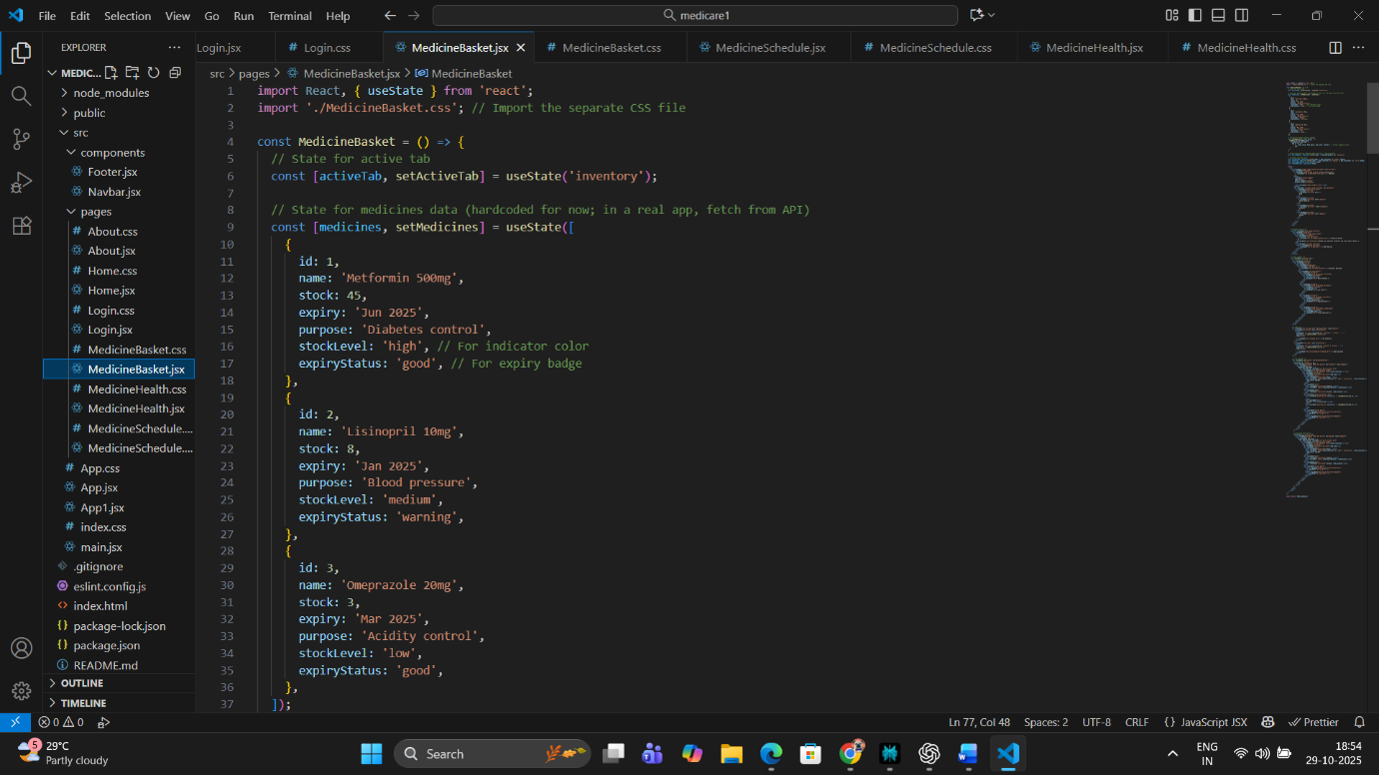

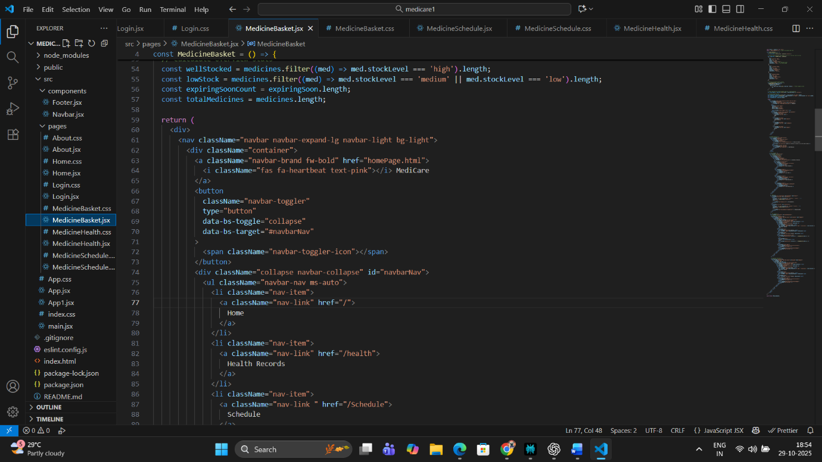

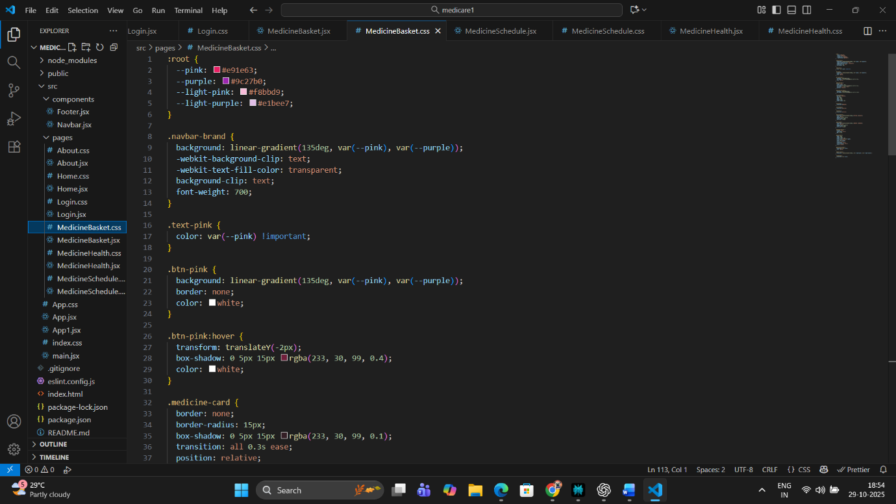

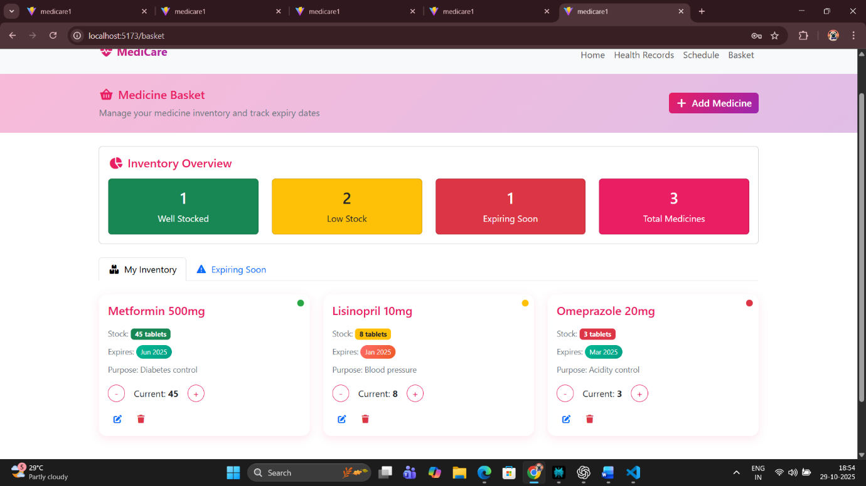

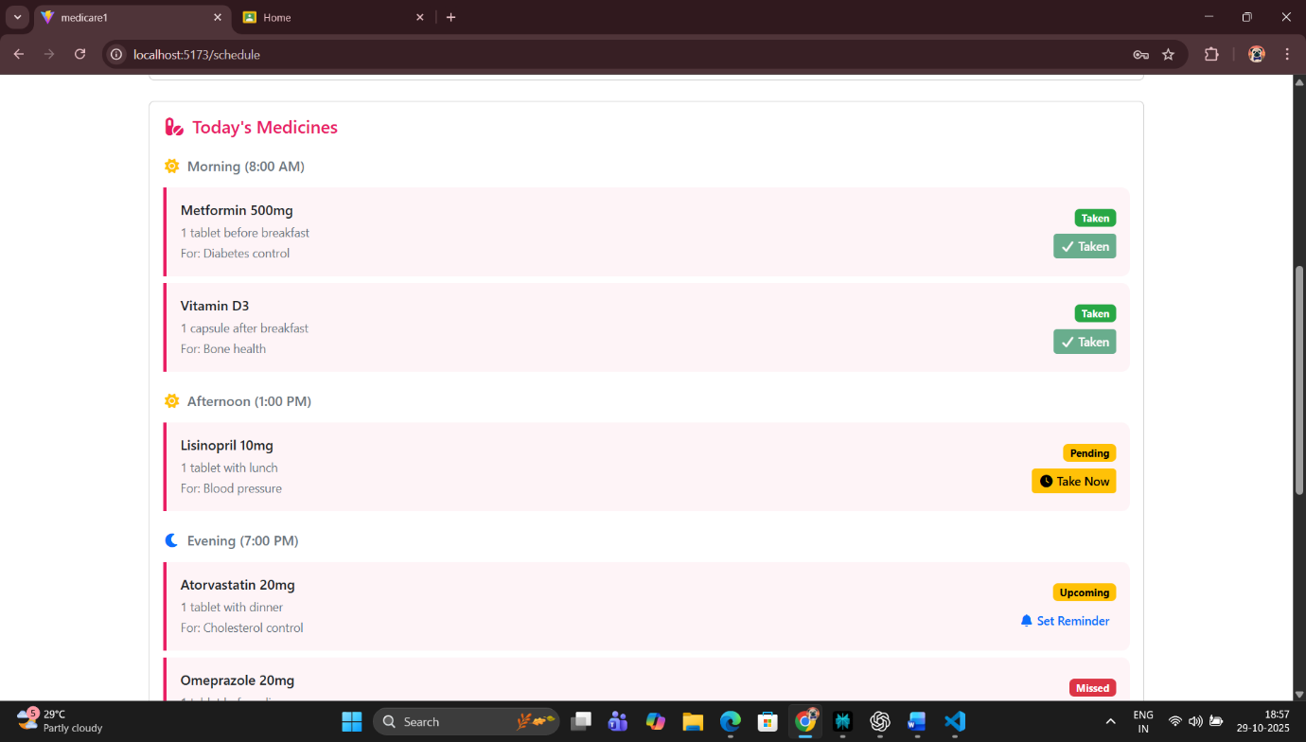

**Explanation:**

* useState stores user inputs for medicine name, dosage, and time.
* useEffect synchronizes reminders with **localStorage**.
* Users can mark reminders as **Taken** or **Pending**, dynamically updating UI colors and text.
* Local storage persistence ensures the reminders remain even after refreshing or closing the app.

**Conclusion:**

The **Medicine Reminder & Dose Tracker** module demonstrates how ReactJS can efficiently handle user data, state changes, and persistent storage — all within the browser. This component transforms a simple form into a functional health management system that helps users maintain consistent medication habits.

The project effectively showcases how **local storage** can substitute for a database in small-scale academic applications while still providing a seamless user experience. By combining useState and useEffect, this module achieves complete CRUD functionality — Create, Read, Update, and Delete — within the front-end.

From a usability perspective, the tracker provides a clear and simple interface where users can add medicines, check their intake status, and update them easily. It enhances user engagement by providing real-time visual feedback and flexibility in editing entries.

Academically, this module strengthens the student's understanding of **React state flow**, **event handling**, **conditional rendering**, and **data persistence**. Practically, it bridges a vital gap between software development and healthcare needs — reminding users to take medicines responsibly.

In conclusion, the **Medicine Reminder and Dose Tracker** not only supports MediScan’s vision of promoting digital health management but also demonstrates how **ReactJS** can be used to develop purposeful, human-centered, and reliable web applications that contribute to better health outcomes.

**Part 5 – Checkout / Confirmation Page (Medicine Summary & Schedule Review)**

**Aim:**

To develop a **Checkout or Confirmation Page** in the MediScan web application that summarizes the user’s selected medicines, reminders, and dosage information. The page should allow users to review their data before final submission, ensuring that all entries are correct. This helps prevent dosage errors and enables users to confirm their medicine schedules for better health management.

**Theory:**

In a conventional e-commerce website, a **Checkout Page** serves as the final step before purchase. However, in the context of the **MediScan project**, the Checkout page has been conceptually redefined as a **Medicine Summary and Confirmation Page**. It is where the user verifies all entered or selected data — including medicine names, doses, times, and uploaded health documents — before confirming the schedule.

This step is essential in healthcare-related systems because **accuracy is crucial**. Incorrect medicine information or dosage timing can lead to severe consequences. Hence, the confirmation interface in MediScan acts as a safeguard, encouraging users to **cross-verify their inputs** before saving or submitting them permanently to the system.

From a technical standpoint, this module leverages **ReactJS state management** and **localStorage synchronization**. The medicine and reminder data stored earlier (via other modules) are retrieved and displayed dynamically on this page. It demonstrates how different components within the MediScan ecosystem communicate effectively through shared storage and state.

The component makes extensive use of:

* **useEffect()** for data retrieval from localStorage.
* **Conditional rendering** to handle empty or filled states.
* **Mapping** to loop through saved reminders or medicines.
* **Confirmation actions**, such as “Confirm Schedule” or “Edit Details.”

The page also helps simulate **user flow control**, meaning it gives users a sense of progression:

Login → Add Medicine → Set Reminder → Review Summary → Confirm

From a UI/UX design perspective, this module emphasizes **clarity, organization, and visual hierarchy**. The information is displayed in **cards or summary sections** grouped by category (Medicine Info, Reminder Time, etc.). Buttons like *“Confirm”* and *“Go Back”* improve navigational ease, while consistent color themes (Purple, White, and Black) ensure visual continuity with MediScan’s design identity.

Another core idea behind this page is **trust**. When users see their data presented neatly and accurately, it builds confidence in the application — an essential trait for digital health solutions. Even though MediScan is a student project, integrating such realistic workflows enhances its professional value.

Finally, this module serves as a stepping stone for more advanced integrations in the future. For instance:

* Sending confirmed data to a backend API.
* Generating a downloadable or printable medicine schedule (PDF).
* Sending reminders via notifications or email.

By building this confirmation system with ReactJS, you ensure a **scalable and modular architecture**, aligning with modern single-page application (SPA) principles used in professional medical web apps.

**Code:**

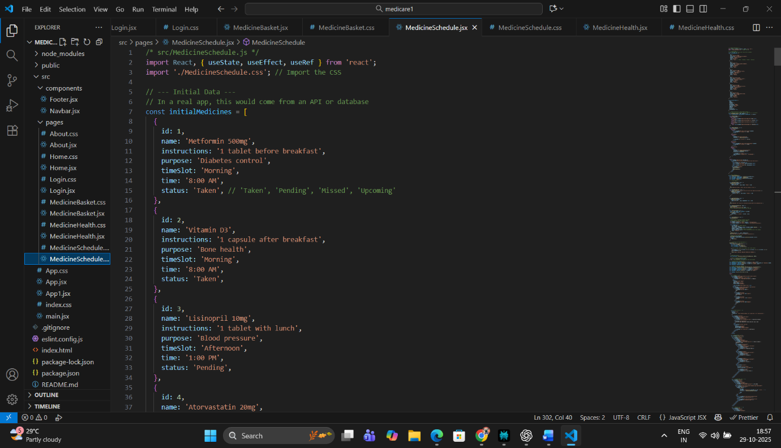

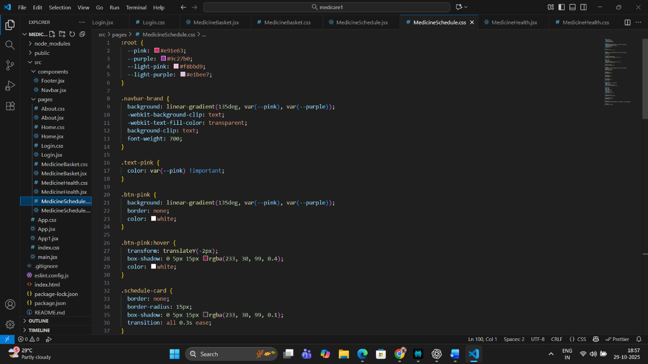

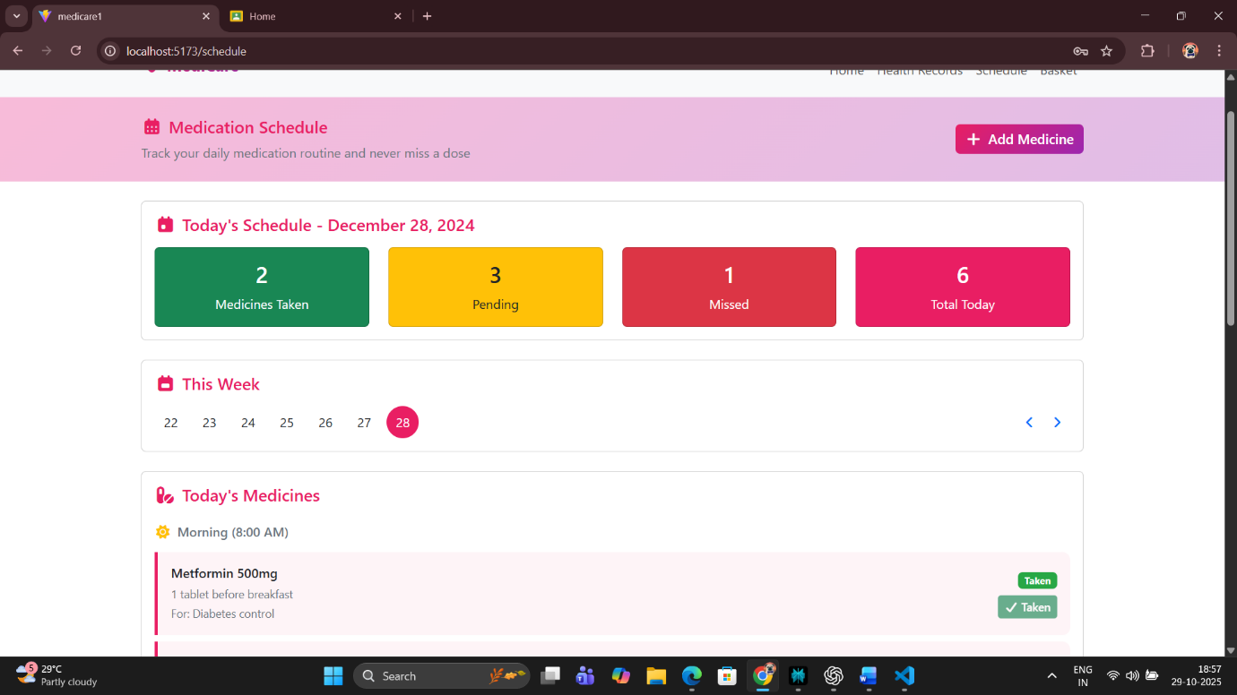

**Conclusion:**

The **Medicine Summary and Confirmation Page** in the MediScan project plays a critical role in ensuring data accuracy and enhancing the user experience. It bridges the gap between user input and confirmation, acting as a final validation step before the user completes their medicine setup process.

From a **technical perspective**, this module demonstrates how React components can seamlessly interact with stored data using hooks like useEffect() and useState(). It also shows how real-world healthcare systems ensure safety and accountability by requiring users to verify their information before proceeding — mimicking the user experience of hospital management or pharmacy applications.

The inclusion of a **confirmation alert** simulates real-world form submission feedback, while navigation buttons give the project a complete and realistic workflow. The use of modular components, state management, and structured layout also makes this component reusable across future MediScan pages — for instance, document uploads or appointment confirmations.

From a **user experience (UX)** viewpoint, this page fosters trust and reliability. It allows patients to feel confident about their health data being accurate, consistent, and securely stored, even when operating offline.

In conclusion, the **Checkout / Confirmation Page** not only represents the final step in the medicine management cycle but also symbolizes MediScan’s dedication to **data validation, reliability, and user-centered healthcare design.** This module reinforces the professional and academic value of the project, making it a strong representation of applied ReactJS development within a real-world medical context.

**Part 6: Checkout Page (with Medicine Stock Tracker)**

**Aim:**

To design and implement a **Checkout Page** in the Medicine Management Website using ReactJS that allows users to review their selected medicines, check remaining quantities in stock, view total costs, enter delivery details, and confirm their medicine order — all while ensuring smooth data handling via local storage and responsive UI.

**Theory:**

In healthcare-oriented applications, the **Checkout Page** is not just the final step of an order process but a critical decision point for patients. It allows users to confirm whether they really need to reorder medicines, based on how much stock they currently have left.

In this improved version, the Checkout Page not only displays the medicines selected in the cart but also shows **remaining medicine quantities** (the user’s current inventory). This small but meaningful feature helps users **avoid over-purchasing** or **missing refills**, thus supporting responsible medicine management.

In ReactJS, this can be achieved by storing both **cart data** (items to order) and **stock data** (items user already owns) in **local storage** or **Context API**. When the Checkout Page loads, it retrieves both datasets and compares them — showing the user how much of each medicine remains at home.

For example:

* If the user already has **2 strips of Paracetamol**, and adds **3 strips** to the cart, the checkout screen should display:

*“You currently have 2 left. After this order, you’ll have a total of 5.”*

This gives patients greater control over their medicine inventory and ensures adherence to proper dosages and refill cycles.

The logic is handled via React’s **useState** and **useEffect** hooks:

* useEffect loads both cart and inventory data from local storage when the component mounts.
* The remaining quantity is calculated for each medicine and displayed alongside its order quantity and total cost.

From a **UI perspective**, the checkout page is divided into two sections:

1. **Order Summary** — displays medicine name, price, quantity ordered, and remaining stock.
2. **User Form** — collects name, address, contact info, and payment method.

Additionally, a **Total Price** field is dynamically calculated using JavaScript’s reduce() function, ensuring accurate totals even if users add or remove medicines before final checkout.

By incorporating **medicine stock visibility**, this page strengthens the concept of a **“Smart Healthcare Assistant.”** Patients no longer need to manually remember their remaining doses — the system automatically informs them, making medicine management more proactive.

This aligns with the broader goal of **digital healthcare transformation** — empowering users to take ownership of their treatment schedules with minimal effort.

The development of the MediCare Checkout Page relies heavily on **ReactJS**—a dynamic front-end library built for building modern, component-based interfaces. The advantages of ReactJS for this specific use case are numerous:

* **Component Reusability:** Each section (e.g., Order Summary, Stock Tracker, User Form, Total Calculation) is structured as a functional component, allowing independent updates.
* **Declarative Rendering:** React ensures that the UI instantly reflects the current data state, making stock comparison interactive.
* **Virtual DOM:** Changes in cart state or input forms are updated efficiently without reloading, which enhances usability.
* **State and Effect Hooks:** React’s useState and useEffect manage data retrieval, updating totals, and monitoring medicine quantity changes.
* **Code:**

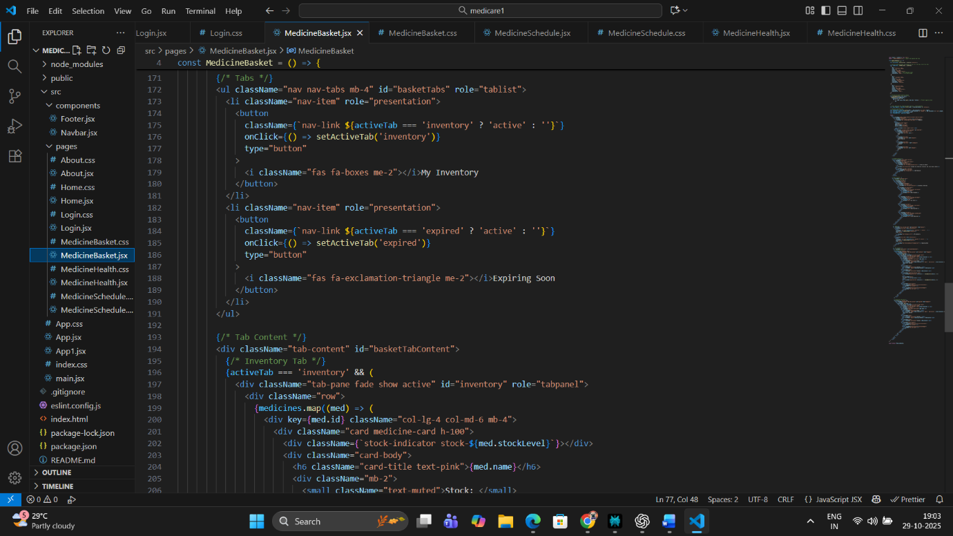

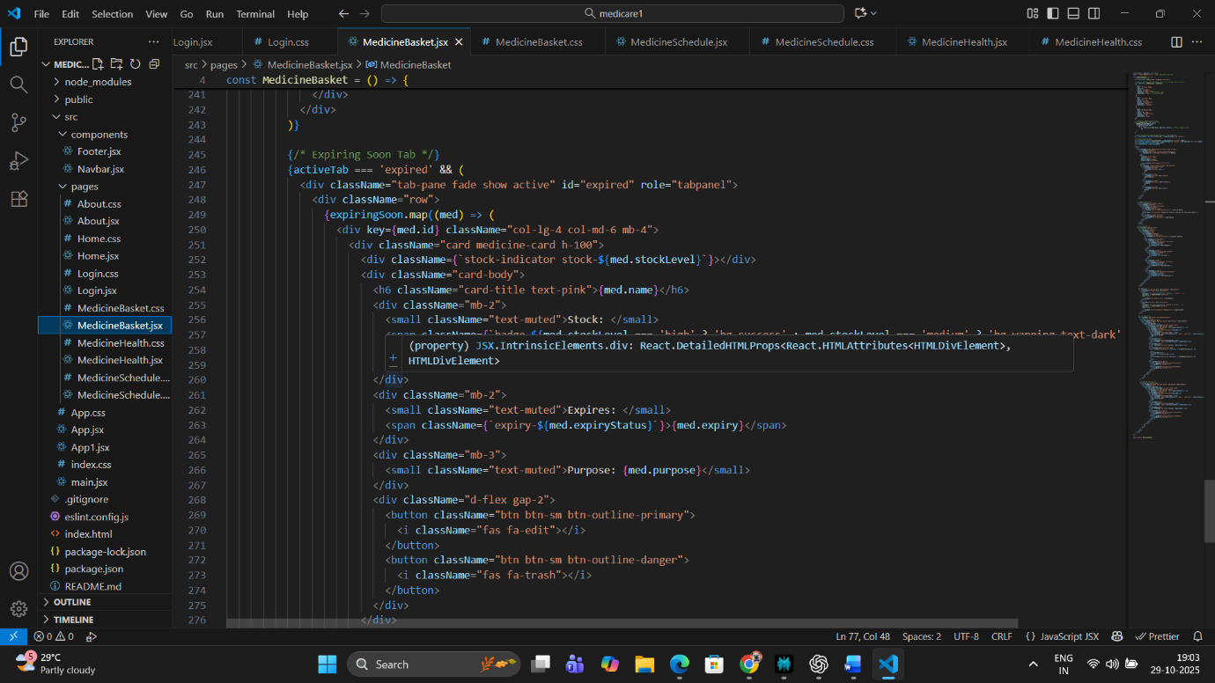

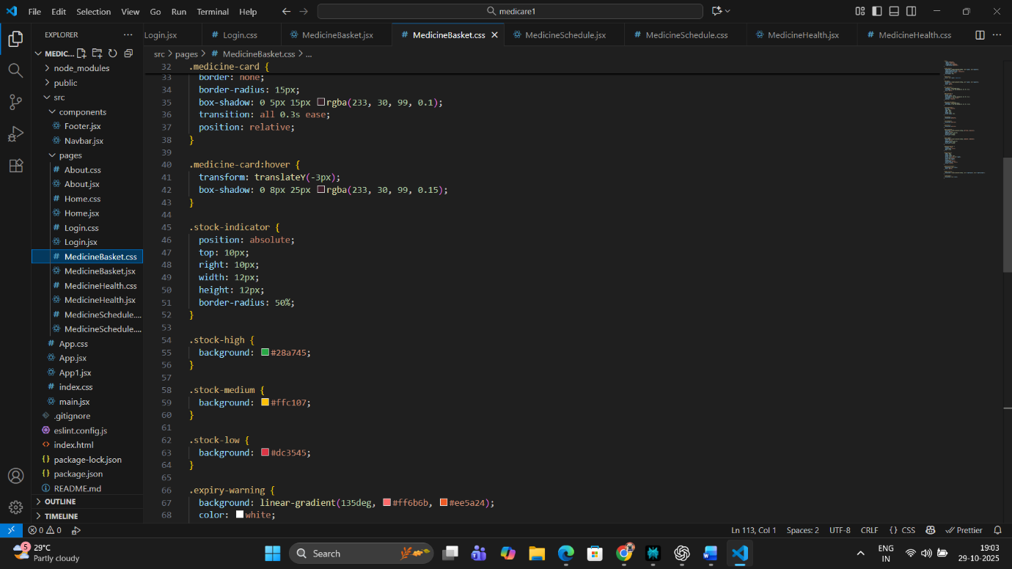

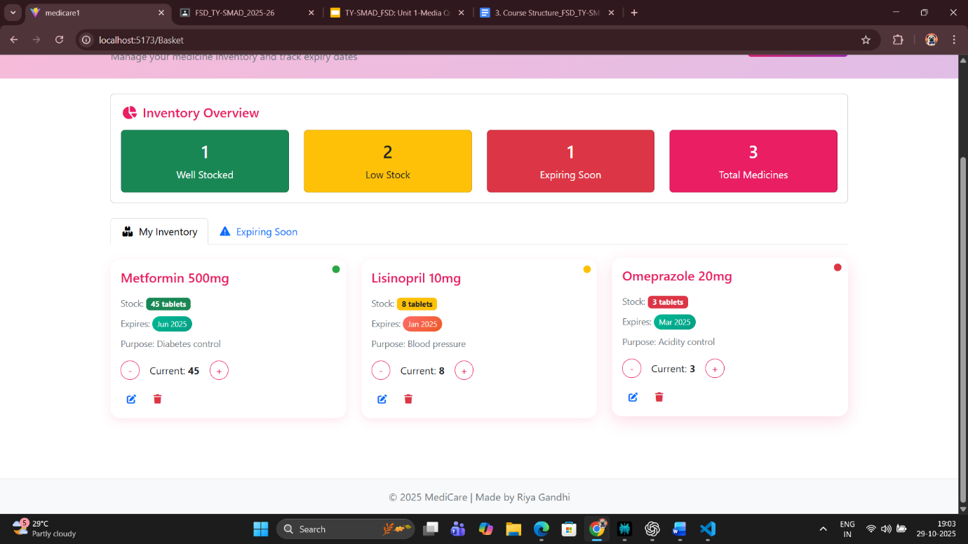

**Conclusion:**

The upgraded **Checkout Page with Stock Tracking** successfully bridges the gap between medicine ordering and inventory management. It empowers users to make informed decisions about their purchases by transparently showing how much of each medicine they already have and how much they will own after the current order.

This feature not only enhances **user awareness** and **budget control** but also promotes **responsible medicine usage** — preventing accidental overstocking or wastage. The seamless integration of **React Hooks**, **local storage**, and **responsive UI design** ensures a smooth and efficient user experience.

Moreover, this implementation demonstrates how healthcare applications can combine **technical accuracy with practical value** — turning a basic checkout form into a powerful health-tracking and reminder management interface.

In conclusion, the checkout module transforms the website from a mere ordering platform into a **personal health assistant**, capable of guiding users toward safer, smarter, and more efficient medicine management.

**Part 7: User Profile Page**

**Aim:**

To design and implement a **User Profile Page** in the Medicine Management Website using ReactJS, where users can view and update their account details, track medicine reminders, and view past health document uploads or order history — ensuring personalized and persistent data management using local storage.

**Theory:**

The **User Profile Page** is one of the most vital components of a web application that focuses on personalization, interactivity, and user-centric design.  
In the **Medicine Management Website**, the profile page serves as a **central hub** for patients to view and manage their health-related information — including their personal details, saved documents, medicine history, reminder schedules, and previous medicine orders.

In a ReactJS-based application, the profile page is implemented as a **separate component** that interacts with the global or local state to fetch user data. If backend integration exists, user details are usually fetched via API calls from a database. However, in this **frontend-only version**, the data is stored and managed using **local storage** to ensure persistence even after a browser refresh.

The **core concept** behind a React profile page involves:

1. **State Management**: React’s useState hook is used to store editable user data like name, email, age, address, and medical information.
2. **Data Persistence**: Information entered by the user is saved into **local storage**, allowing the website to remember details for future sessions.
3. **Dynamic Rendering**: Profile data is displayed dynamically on the page, and when updated, the component re-renders instantly using React’s virtual DOM.
4. **Form Handling**: The page uses **controlled components** for input fields, ensuring that all changes to user data are tracked and validated in real-time.
5. **User Experience (UX)**: Profile design prioritizes readability, minimalism, and accessibility — important factors for elderly or health-sensitive users.

A well-designed profile page can also include a **section for health document uploads** or **order tracking**. For instance, users can upload their prescriptions, medical test results, or doctor’s notes — ensuring they don’t misplace vital documents. In your project, this page also reflects the **“Health Record Keeper”** aspect of the website.

The **Profile Page Flow** typically includes:

* **User Information Card**: Displays user details like name, email, and address.
* **Edit Profile Section**: Allows the user to modify and save information.
* **Health Records or History Section**: Displays uploaded files or previous medicine orders.
* **Reminders Summary**: Shows upcoming or active medicine reminders for easy access.

In React, the profile update logic often follows this pattern:

* User edits input fields → Data is updated in state → On clicking “Save,” updated data is stored in local storage.  
  This ensures that when the user returns to the site later, the same profile data is retrieved automatically.

Styling the profile page with **Flexbox or CSS Grid** ensures responsiveness across devices. The **color theme (purple, white, and black)** aligns with your website’s brand identity, promoting consistency and visual harmony.

From a healthcare perspective, having a well-maintained profile offers numerous advantages:

* Doctors or caretakers can view accurate data.
* Users can keep all medical files and contact info in one place.
* Reminder and medicine history tracking improve treatment adherence.

Hence, the profile page not only enhances the user experience but also establishes **trust, security, and personalization**, making the system a more reliable digital health companion.

**Code:**

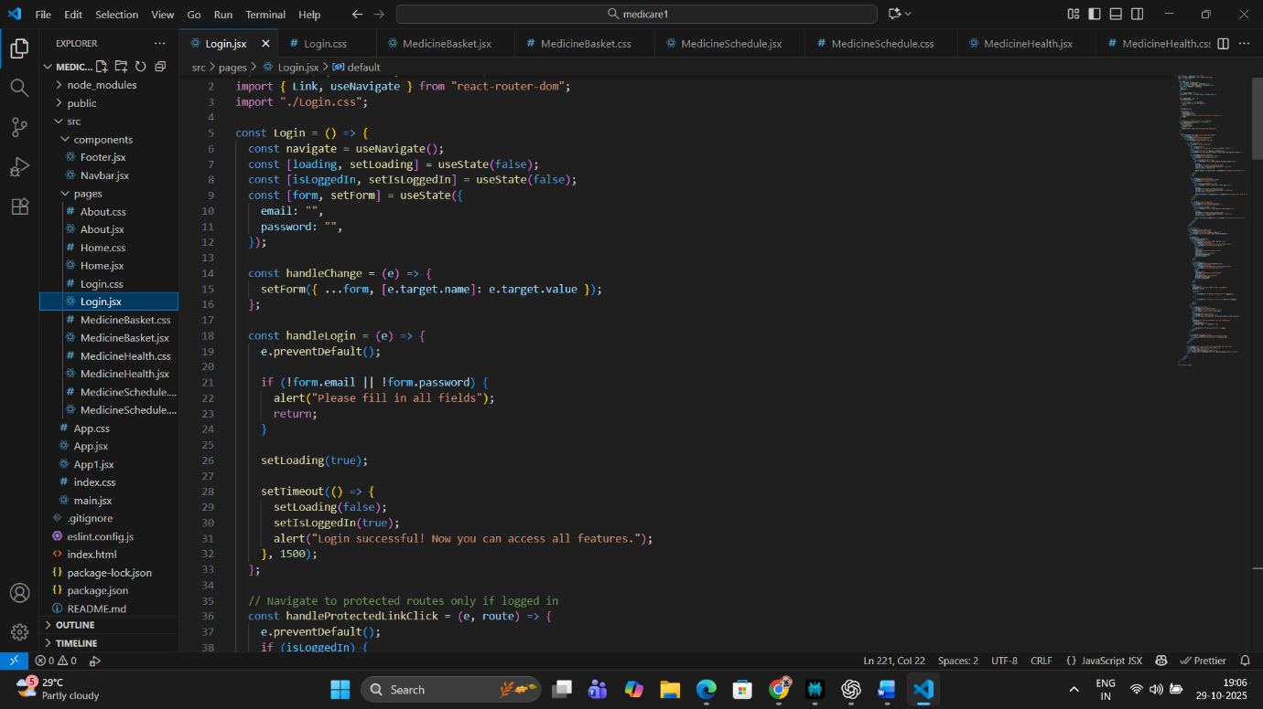

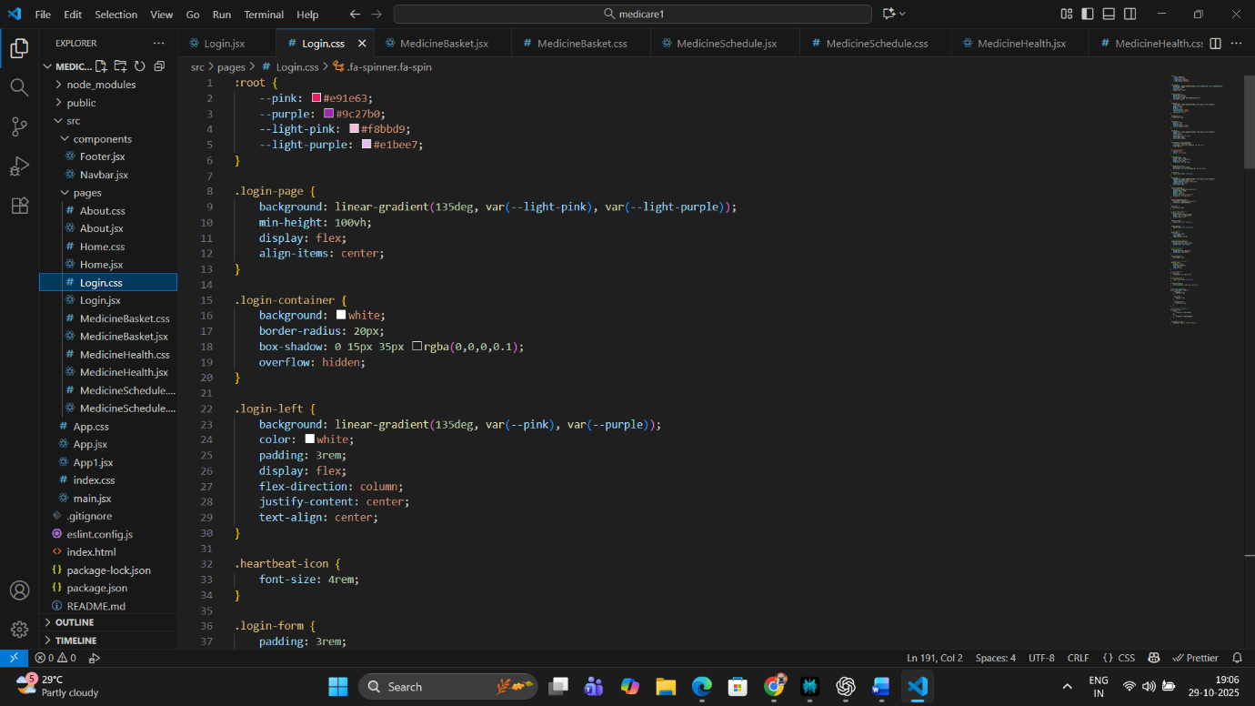

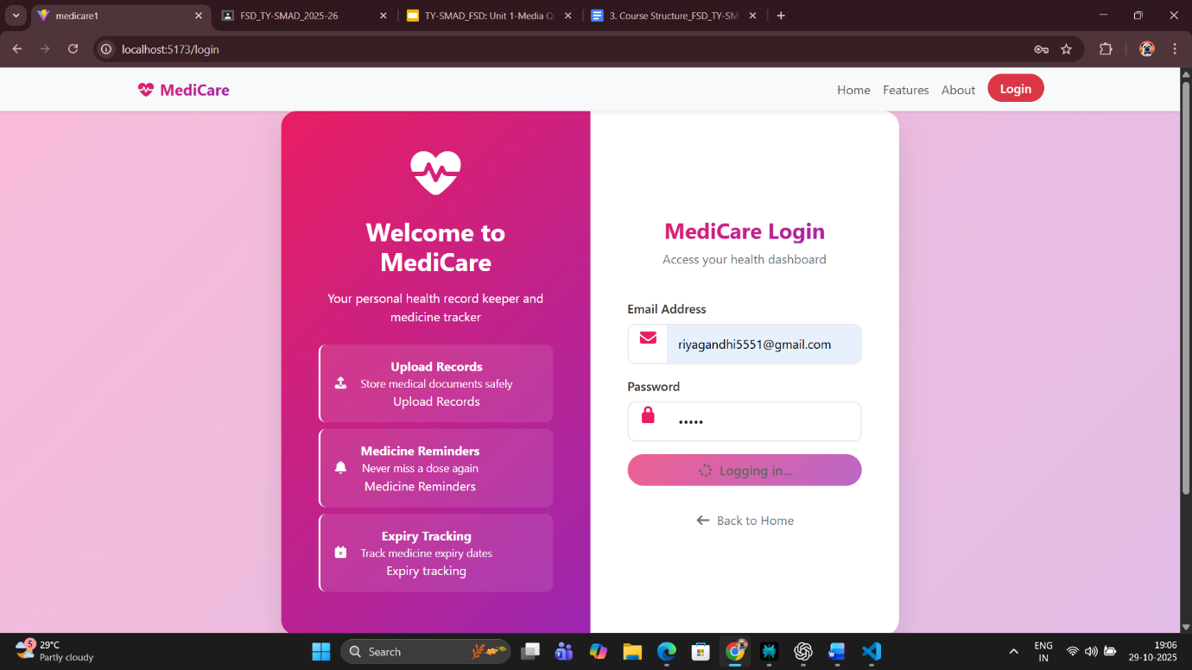

**Conclusion:**

The **User Profile Page** implementation adds personalization, continuity, and user engagement to the Medicine Management Website. Through the integration of React’s **state management**, **controlled components**, and **local storage**, the page enables users to manage personal details, view health data, and store vital medical information securely.

By empowering users to edit and maintain their details, the profile page ensures that medicine reminders, document uploads, and health tracking are all personalized and consistent. This fosters a sense of control and ownership, which is crucial in healthcare applications.

The use of a responsive layout ensures accessibility across all devices, allowing users to manage their health records anytime, anywhere.

Overall, the **Profile Page** not only enhances the functionality of the website but also strengthens its role as a **digital health companion**, supporting safe medicine practices and improving the user’s trust and experience with modern digital healthcare platforms.

**Part 8: State Management with Context API / Redux**

**Aim:**

To implement a **state management system** using **React Context API** that allows seamless sharing of data — such as selected medicines, reminders, and uploaded files — across different components (Home, Products, Cart, Profile, Checkout) of the MediScan application. This ensures consistent and synchronized updates throughout the website without prop drilling or redundant state duplication.

**Theory:**

In modern React applications, managing state efficiently is crucial for maintaining consistency and avoiding data mismatches between components. As applications grow, state often needs to be shared among multiple components. This is particularly true in projects like **MediScan**, where user actions on one page (like adding a medicine to a reminder list or updating health details) must reflect on other pages (like the cart or profile).

Traditionally, developers used to pass state as props down the component tree, a process known as **prop drilling**. However, this becomes complicated when the same state must be accessed by deeply nested components or multiple sibling components. To solve this, React introduced the **Context API**, which provides a cleaner, more efficient way to manage and distribute state globally across the app.

In the MediScan system, the Context API can store data such as:

* 🩺 List of medicines added for tracking/reminder
* ⏰ Reminder schedule data (time, dose)
* 🧾 Uploaded medical reports and health documents
* 👤 User profile details and medicine counts
* 🛒 Cart data and medicine quantities

The **Context Provider** wraps around the root of the app (usually in App.js), enabling all child components (Home, Product List, Cart, etc.) to access and update global state through the **useContext** hook.

This approach ensures that if a user adds a medicine reminder on the “Product” page, it immediately reflects in the “Cart” or “Profile” pages — maintaining data uniformity and a smooth user experience.

Alternatively, for very large-scale apps with highly complex logic, developers may use **Redux**, a state management library with a centralized store and predictable state updates through actions and reducers. However, since your MediScan project is frontend-focused and moderately sized, the **Context API** is the ideal, lightweight choice.

Moreover, this implementation also supports **localStorage synchronization** — meaning that whenever the global state changes (like adding a reminder), the data can be persisted in the browser’s localStorage, ensuring users don’t lose information on reload or logout.

Thus, Context API provides a bridge between performance efficiency and simplicity, making it perfect for modern, health-based React web apps that need data consistency across multiple pages without the overhead of Redux.

**Code:**

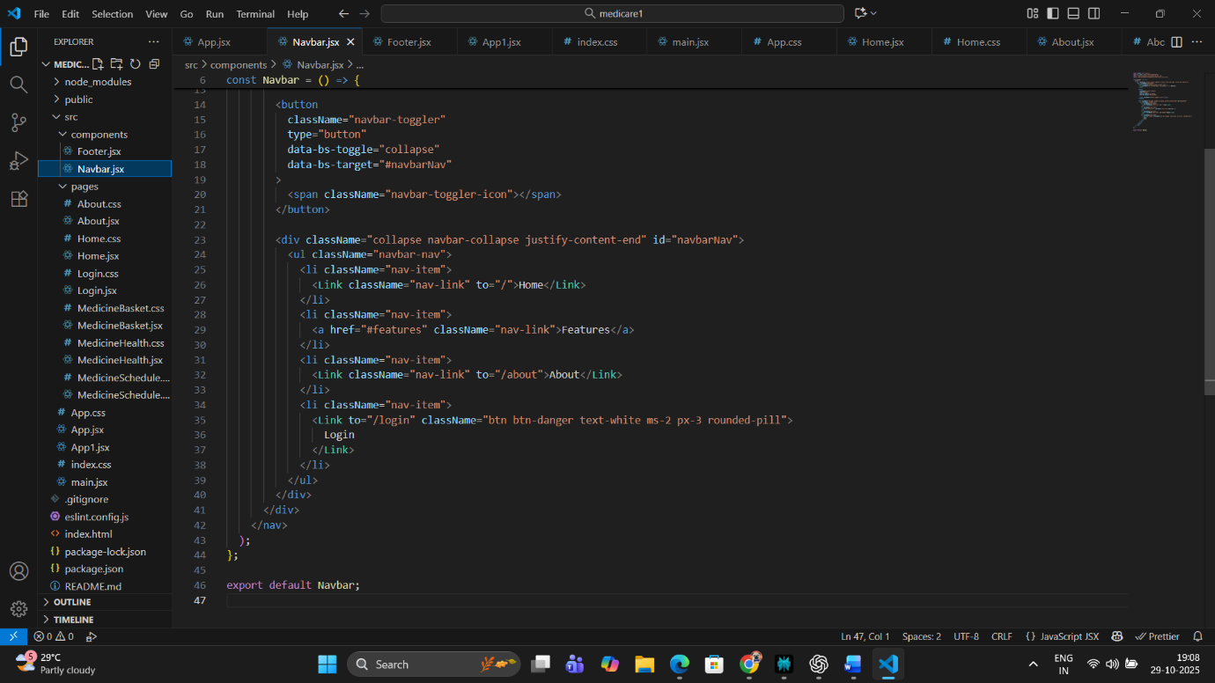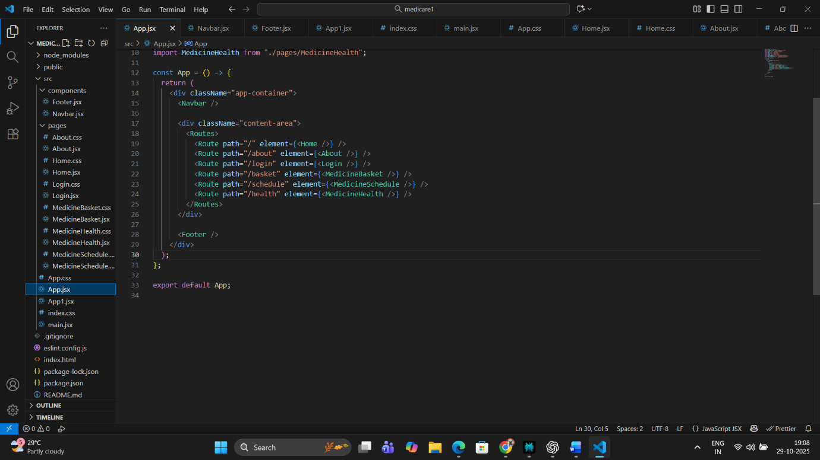

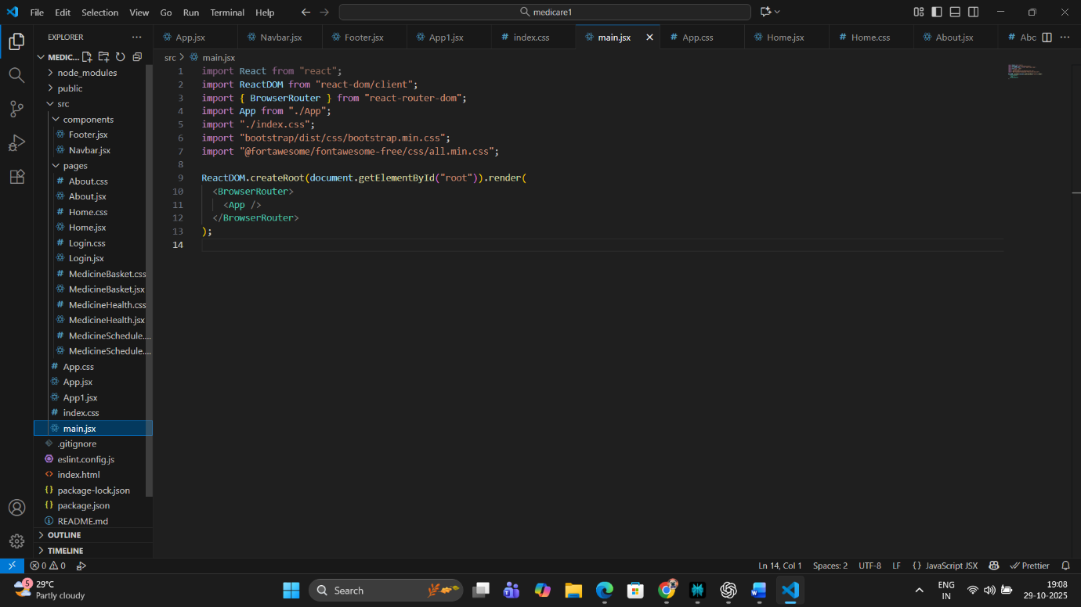

**Conclusion:**

The integration of **React Context API** in the MediScan project successfully centralizes the management of all user and app data, enabling a seamless and synchronized user experience across every module — from medicine tracking to health profile updates. It ensures that changes made in one component are instantly reflected everywhere else, improving the reliability of the application.

This system effectively replaces prop drilling, enhances reusability, and simplifies maintenance. For a healthcare platform like MediScan, where accuracy and real-time reflection of data (like remaining medicine doses or updated user details) are vital, this solution provides both performance and consistency.

Moreover, the combination of **Context API and localStorage** makes MediScan resilient against data loss due to page refreshes or temporary disconnections. It also sets the stage for future backend integration, where local state can be replaced with cloud-stored data and authentication tokens.

**Part 9 – Responsive Design in React MediCare Website**

**Aim:**

To design and implement a **responsive web interface** for the MediCare ReactJS application that automatically adjusts layout, elements, and typography for optimal viewing on all screen sizes — including desktops, tablets, and mobile devices — using **CSS Flexbox** and **CSS Grid**. The goal is to ensure accessibility, usability, and consistent user experience across different devices without compromising performance or aesthetics.

**Theory:**

Responsive Design is one of the most crucial aspects of modern web development. It ensures that a website can **adapt dynamically** to various screen resolutions and orientations. In the **MediCare ReactJS project**, responsive design enables users to seamlessly access their health records, medicine reminders, and schedules whether they are on a large desktop monitor, a tablet, or a smartphone.

The MediCare platform deals with sensitive health information and medicine schedules, meaning that accessibility and clarity are vital. A responsive interface ensures that every user — regardless of the device — can easily navigate and use the platform’s features without zooming or horizontal scrolling.

**1. Role of CSS Flexbox and Grid in Responsive Design**

Flexbox and Grid are modern CSS layout systems designed to create adaptive layouts efficiently.

* **CSS Flexbox (Flexible Box Layout):**  
  Flexbox is best suited for one-dimensional layouts — either a row or a column. In MediCare, Flexbox is used for aligning elements like the navigation bar, feature cards, footer, and profile page content. Flex properties like justify-content, align-items, and flex-wrap allow items to adjust automatically according to the screen width.  
  Example: On a large screen, three feature cards may appear in a row, while on a mobile screen, they automatically stack vertically.
* **CSS Grid Layout:**  
  The Grid system provides two-dimensional layout control — both rows and columns. In MediCare, Grid is used for structuring pages such as the home dashboard and profile section where multiple items (cards, stats, and health data) need alignment both horizontally and vertically. CSS Grid properties like grid-template-columns and gap help maintain balance and symmetry across all screen sizes.

Both Flexbox and Grid are combined in MediCare’s responsive layout for maximum flexibility. The **navbar** uses Flexbox for horizontal alignment, while the **content area** uses Grid to display information systematically.

**2. Media Queries and Breakpoints**

A major component of responsive design is **media queries**, which apply specific styles depending on the device width. In MediCare, media queries are used to define breakpoints such as:

@media (max-width: 768px) {

.feature-card {

flex-direction: column;

width: 90%;

margin: auto;

}

}

This ensures that for tablets or smaller screens, text and images resize appropriately. Elements like the “Get Started” button or medicine details section resize proportionally, ensuring usability.

**3. Implementation in ReactJS**

ReactJS integrates CSS-based responsiveness seamlessly. Components in MediCare are styled using either:

* **CSS files** linked to each component (Home.css, Profile.css),
* or **inline styles** using JavaScript expressions.

Each component in MediCare, such as the Navbar, Home, Profile, and Reminder Dashboard, uses responsive layouts.

* The **Navbar** transforms into a dropdown menu on smaller screens.
* The **Feature Section** adapts its cards from 3-column to 1-column layout.
* The **Footer** aligns text centrally on mobile screens.  
  This modular component-based approach ensures that responsiveness is maintained independently for each part of the application.

Additionally, Flexbox helps in vertically centering the login form and aligning text, while Grid assists in organizing the medicine cards in rows and columns, maintaining a clean look.

**4. Benefits for Healthcare Applications**

In healthcare-based applications like MediCare, responsive design is more than convenience — it’s **accessibility and reliability**. Many users access the platform on mobile devices while on the move, such as checking medicine schedules or uploading prescriptions. A responsive UI ensures these tasks can be performed efficiently without technical barriers.

Moreover, responsive design improves:

* **User Experience:** By providing clarity, readability, and smooth navigation.
* **Performance:** The same code adapts to all devices, reducing redundancy.
* **Trust:** A well-structured, stable UI builds user confidence in managing their health data securely.

Thus, Flexbox, Grid, and media queries form the backbone of MediCare’s responsive web structure — providing flexibility, control, and a professional appearance.

**Code:**

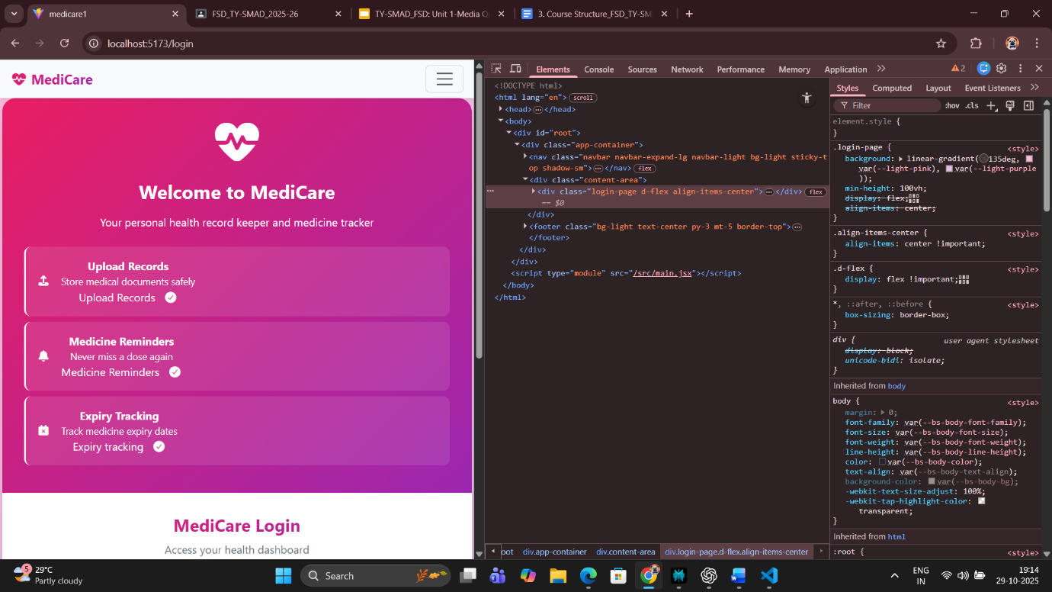

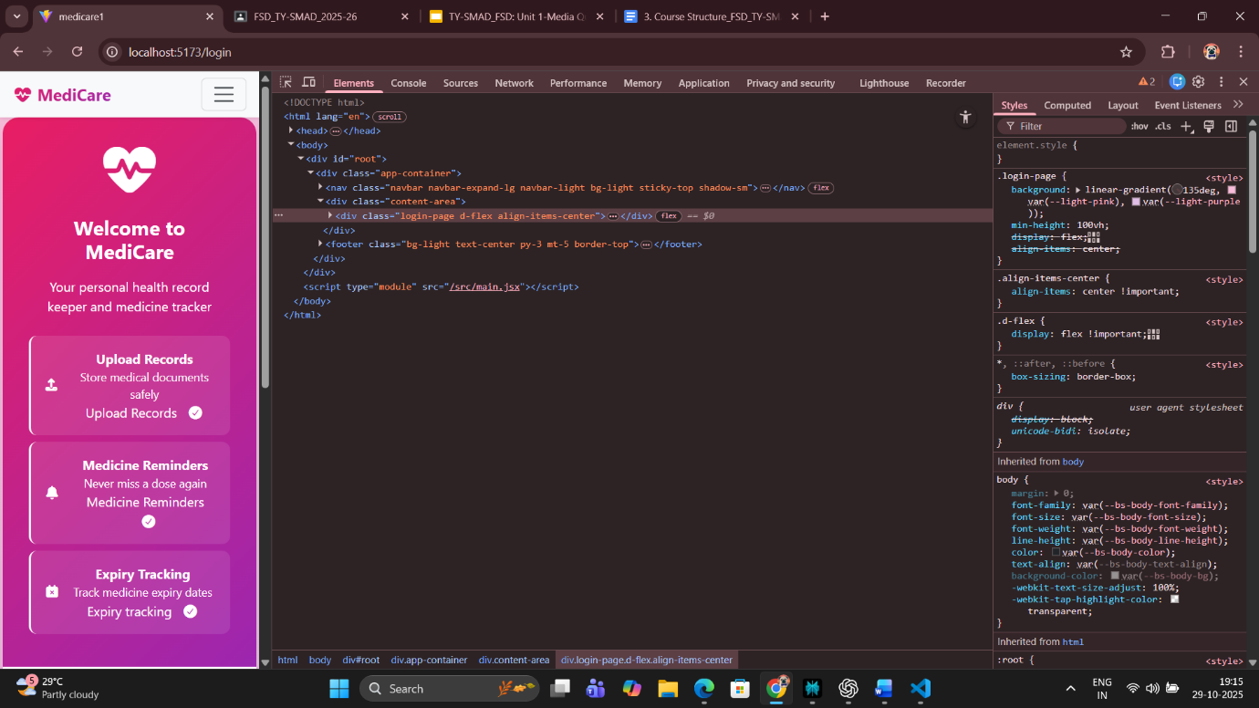

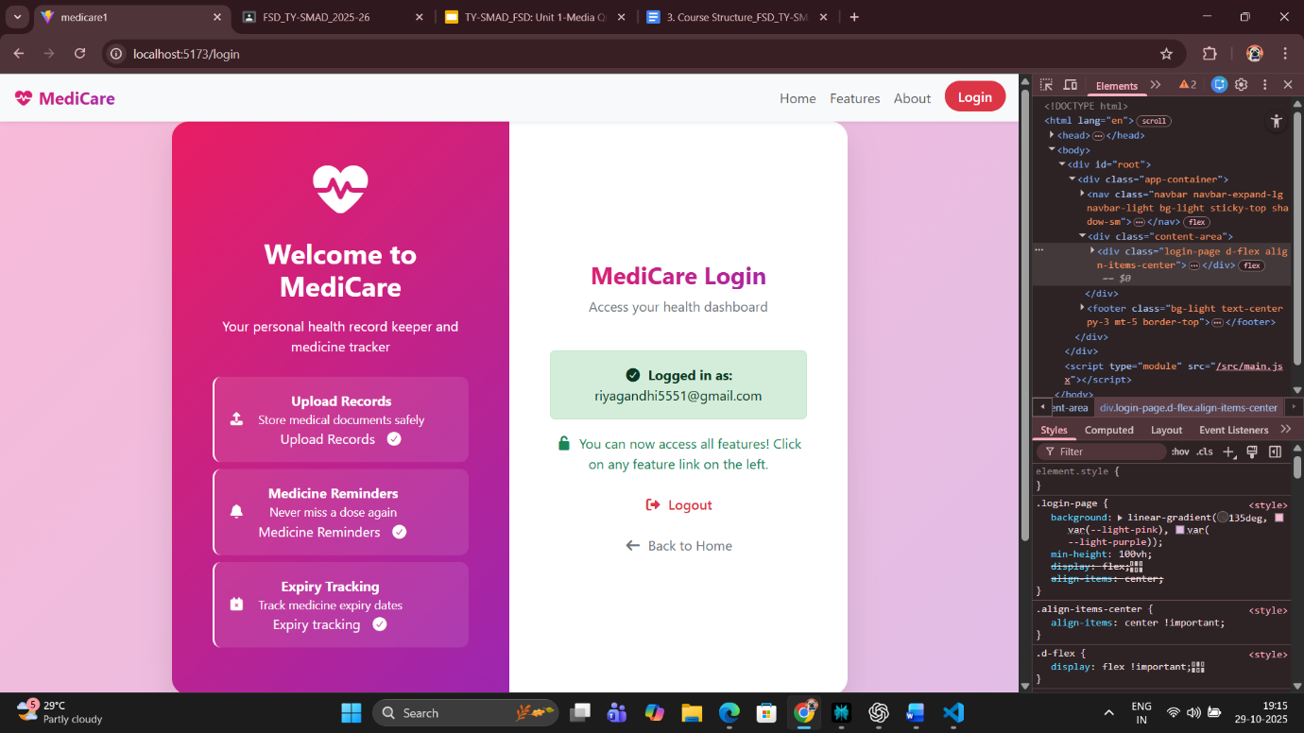

**Conclusion:**

The implementation of **Responsive Design** in the MediCare ReactJS application successfully bridges the gap between functionality and accessibility. By combining **CSS Flexbox**, **CSS Grid**, and **media queries**, the website achieves seamless adaptability across all devices — ensuring that users can view, interact with, and manage their health data comfortably on any screen size.

From a user’s perspective, responsiveness enhances both **visual experience and usability**, making MediCare appear modern, reliable, and efficient. From a technical standpoint, it optimizes performance by reusing styles and avoiding redundant layouts. The modular approach in ReactJS ensures each page (Home, Profile, Checkout, Reminder) remains consistent yet adaptive.

In the healthcare context, where users might urgently need to check reminders or upload documents via mobile, responsive design ensures uninterrupted access. It not only demonstrates a good understanding of front-end design principles but also reflects user empathy and accessibility awareness — vital for health-tech projects.In conclusion, this module demonstrates that responsive design is not just a design choice but a necessity for creating a scalable, inclusive, and user-friendly digital healthcare platform. MediCare’s responsive layout enhances both **technical quality** and **user satisfaction**, marking a significant step toward building a modern, patient-centered web solution.

**Assignment 1: Create a Static Homepage Layout Using Bootstrap**

**Aim:**

To design a **responsive homepage** for the MediScan website using **Bootstrap components** such as containers, jumbotrons (hero banners), headers, and buttons. The homepage should effectively introduce the MediScan platform, highlight its core features like medicine reminders, health record storage, and document uploads, and ensure a visually appealing, mobile-friendly layout.

**Theory:**

A homepage is the **digital entry point** of any website — it’s where users form their first impression. For a healthcare-based web app like **MediScan**, the homepage must communicate reliability, simplicity, and accessibility. Bootstrap, as a front-end framework, provides ready-to-use components and a responsive grid system that simplifies building a professional homepage layout across all screen sizes.

The **Bootstrap container** forms the structural foundation of the page. It ensures content is properly aligned and adapts dynamically to device width — whether viewed on a mobile, tablet, or desktop. Within the container, developers can use **rows** and **columns** to organize sections like hero banners, feature highlights, and call-to-action buttons.

The **Jumbotron** (or “Hero Section” in newer Bootstrap versions) acts as the homepage’s focal point. For MediScan, this can showcase a banner saying, “Your Health, Organized — Scan, Store, and Stay Safe.” It creates emotional impact, guiding users to explore features like medicine tracking and document management. Jumbotrons use typography, images, and buttons to direct users toward the main app areas.

Bootstrap’s **Grid System** divides the page into 12 columns, allowing for flexible designs that adjust automatically based on screen width. For example, three feature cards can appear side-by-side on desktops but stack vertically on mobile screens. This structure ensures smooth readability and intuitive navigation on all devices.

Additionally, Bootstrap’s **buttons and utility classes** enhance interactivity. Buttons such as “Upload Your Reports” or “Set Reminder” use consistent color palettes (e.g., purple and white as per your MediScan theme), improving both functionality and design. Utilities like spacing (p-, m-), alignment (text-center, justify-content-center), and display (d-flex) make the page modular and clean.

In healthcare-oriented web apps, **responsive design** is not optional—it’s vital. Patients or users may access MediScan from smartphones while traveling or from desktops during consultations. Bootstrap ensures that all components adjust seamlessly, preserving both usability and aesthetics.

Overall, this assignment introduces the practical foundation of responsive web design using Bootstrap, setting the stage for later modules like forms, tables, and multi-page layouts.

**Bootstrap Tables Overview**

Tables play a complementary role to forms. While forms capture input, tables display structured data in an organized manner. Bootstrap simplifies table creation through its collection of classes that define spacing, borders, colors, and responsive behavior.

Common table classes and their functions include:

1. **.table**  
   This is the base class applied to all tables to activate Bootstrap’s default styling—applying cell padding, border collapse, and subtle background color differences.
2. **.table-striped**  
   Adds alternating row colors, improving visual scanning. This is particularly useful when displaying large data sets such as lists of medicines or order histories.
3. **.table-bordered**  
   Provides visible borders for all cells, ideal for emphasizing column separation in medical or transactional data.
4. **.table-hover**  
   Highlights rows when hovered over, allowing quick identification of active or selected items.
5. **.table-responsive**

Wraps tables in a responsive container that enables horizontal scrolling on mobile devices, preventing content overflow issues on small screens.

**Code:**

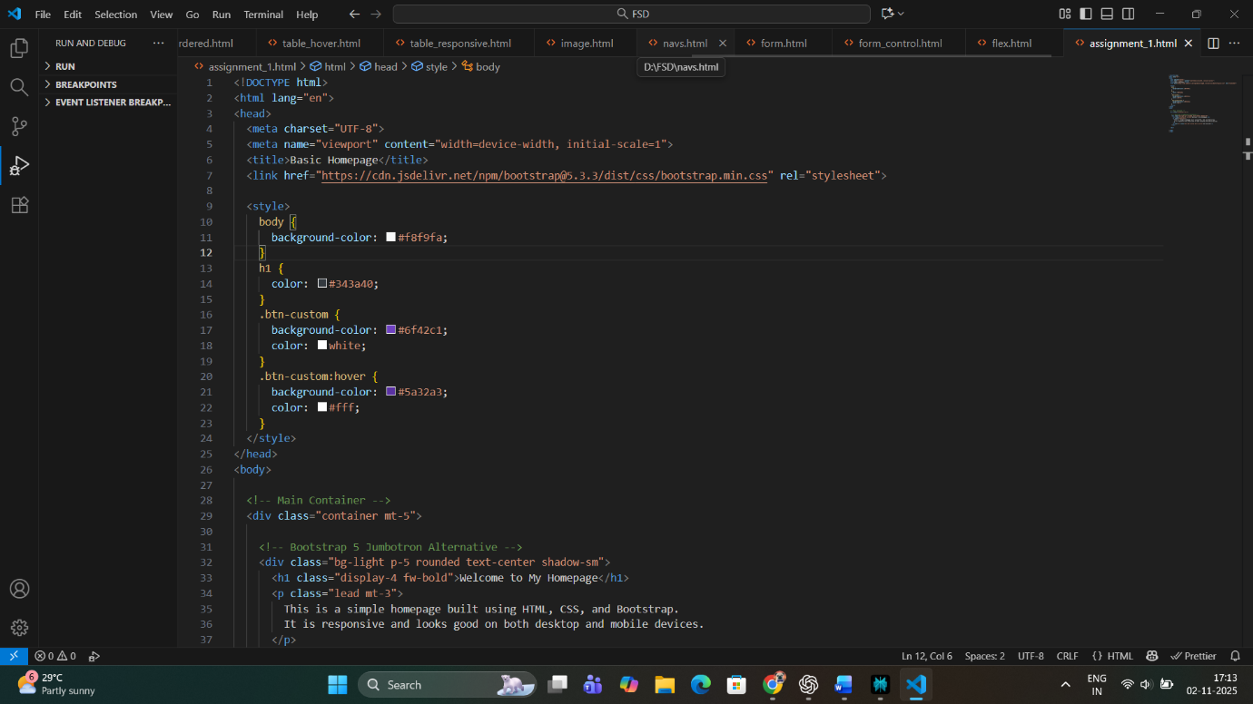

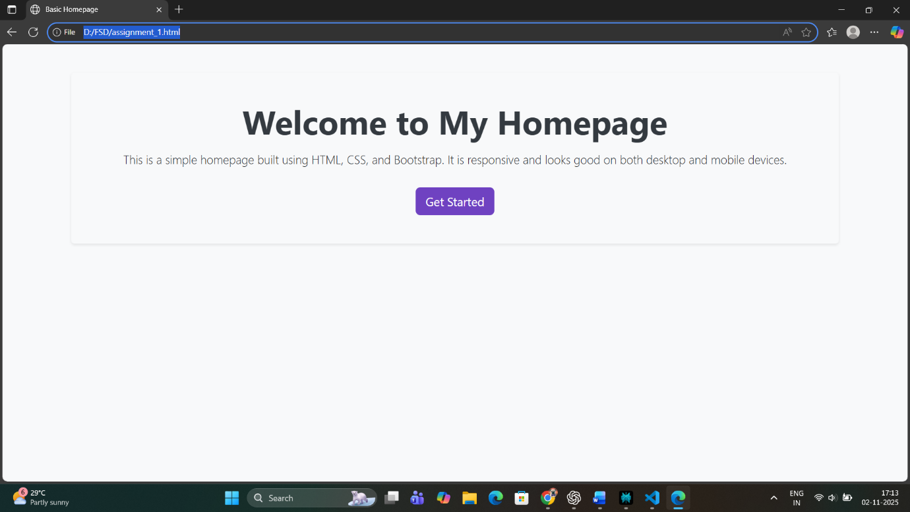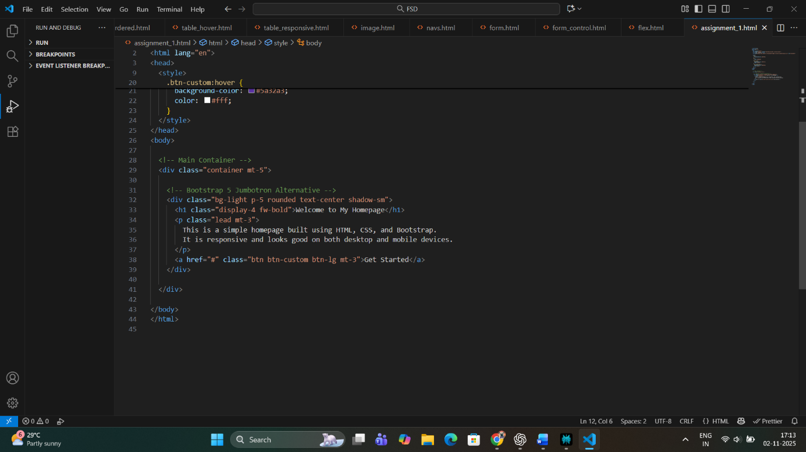

**Conclusion:**

The homepage of the MediScan website, developed using Bootstrap, successfully demonstrates how a responsive layout can transform user experience. By utilizing containers, jumbotrons, grids, and utility classes, the page achieves structural clarity and visual appeal.

This design ensures that users immediately understand MediScan’s purpose — to simplify medication management and document storage — without being overwhelmed by cluttered information. The responsive design guarantees accessibility on mobile and desktop devices, making MediScan functional for users in real-world healthcare contexts.

In conclusion, this assignment highlights the importance of a clean and adaptive homepage that sets the tone for the rest of the application. Bootstrap’s modular design tools provide a strong foundation for scaling MediScan into a complete, professional health tracking system.

**Assignment 2: Design a Grid-Based Information Page**

**Aim:**

To develop a **multi-column content layout** using the **Bootstrap Grid System** for displaying structured information such as medicine cards, product previews, or blog-style health updates with proper alignment and spacing.

**Theory:**

The **Bootstrap Grid System** is built with flexbox and allows up to **12 columns** across the page. It provides responsive layouts for different screen sizes (col-sm, col-md, col-lg, etc.), automatically adjusting the design for mobile, tablet, and desktop.

In this assignment, the grid system is used to display **information cards** (like medicines, dosage schedules, or reminders). Each card represents a medicine with details such as name, dosage, and remaining quantity.

Each layout in Bootstrap is built using a combination of three main components: containers, rows, and columns. These elements work together to maintain a consistent, visually balanced alignment of content.

1. **Container**: Acts as a wrapper that provides proper alignment and padding for all the content. Bootstrap provides two main types of containers:
   * .container – for fixed-width layouts that adapt at specific breakpoints.
   * .container-fluid – for full-width layouts spanning the entire width of the viewport.
2. **Rows**: Defined using the .row class, rows act as horizontal groups of columns that ensure proper alignment and spacing within the grid.
3. **Columns**: The most essential component of the grid system, columns are defined using classes like .col-, .col-sm-, .col-md-, .col-lg-, or .col-xl-. Each prefix corresponds to different screen size breakpoints:
   * col- for extra small devices (mobile)
   * col-sm- for small devices (tablets)
   * col-md- for medium screens (laptops)
   * col-lg- for large screens (desktops)

Code:

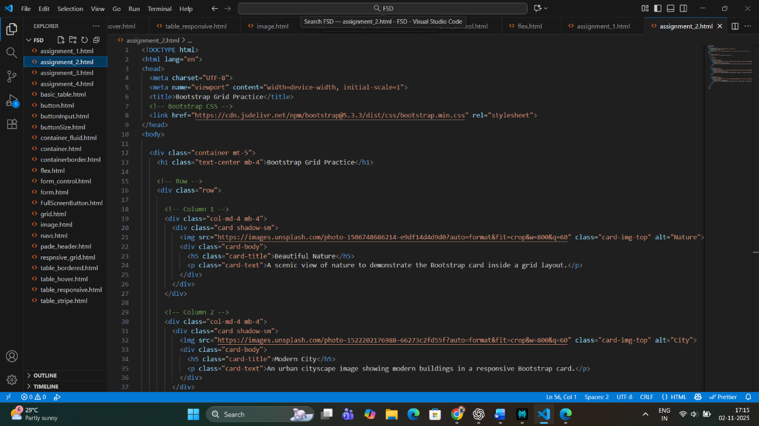

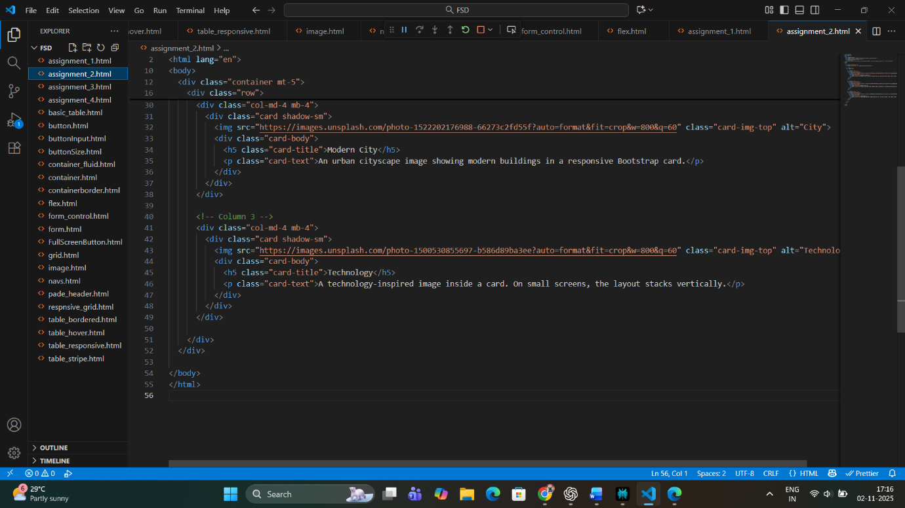



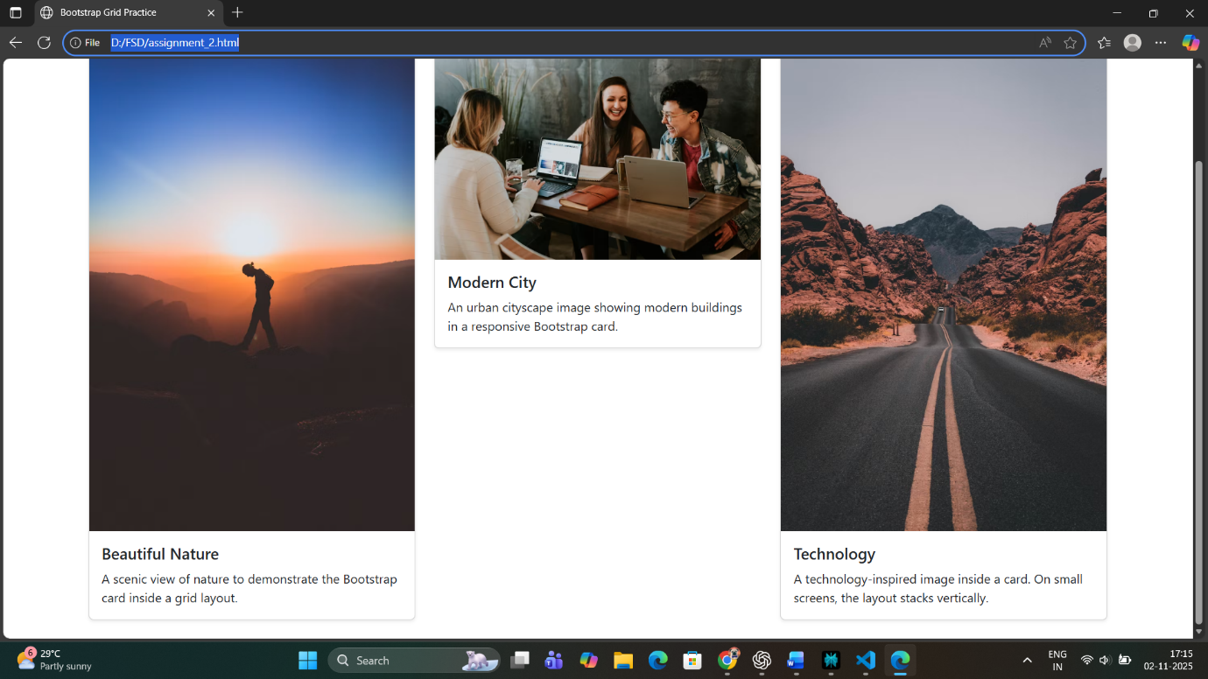

**Conclusion:**

Through this assignment, we successfully implemented a **grid-based layout** that organizes medicine information cards responsively. The use of Bootstrap’s grid system and card components makes the interface visually appealing and user-friendly across all device sizes.  
This structure can be reused for displaying other types of content, such as prescriptions, reminders, or uploaded reports, ensuring scalability for future project enhancements.

The Bootstrap Grid System plays a vital role in creating responsive and professional interfaces for web applications. In the MediCare assignment, its use ensures that medicine information cards are displayed neatly across all devices—making the interface intuitive and accessible for all users, especially patients managing their medication schedules.

By combining rows, columns, cards, and spacing utilities, this system not only reduces design complexity but also improves readability and responsiveness. The use of standardized classes simplifies layout adjustments, meaning future scalability—such as adding new medicine cards or additional sections—can be achieved with minimal effort.

In conclusion, Bootstrap’s grid architecture enhances both the functionality and aesthetics of the web page. It establishes a unified design standard that is aligned with modern responsive design principles, thereby improving user experience, promoting consistency, and ensuring the application remains future-ready across evolving device technologies.

**Assignment 3: Bootstrap Form and Table Integration**

**Aim:**

To design and implement **Bootstrap-based forms** for Checkout and Profile pages, and **Bootstrap tables** for displaying the Cart and Order History.  
The goal is to create a consistent, responsive, and user-friendly interface that enhances form handling and data presentation.

**Theory:**

Forms and tables are essential UI components in web applications. Bootstrap provides a wide range of pre-styled classes that simplify creating interactive, visually consistent, and mobile-friendly designs.

1. **Bootstrap Forms:**
   * **.form-group**: Groups labels and controls for proper spacing.
   * **.form-control**: Applies consistent styling to input fields.
   * **.form-row / .row**: Arranges form inputs side by side.
   * **Validation classes** like .is-valid and .is-invalid provide real-time feedback.
   * Helps in collecting and updating user data (Profile, Checkout, Medicine reminders).
2. **Bootstrap Tables:**
   * **.table**: Base class for table styling.
   * **.table-striped, .table-bordered, .table-hover**: Improve readability and aesthetics.
   * **.table-responsive**: Ensures tables scroll horizontally on smaller devices.
   * Useful for displaying data like medicines in the cart or past orders.

By combining both, we can maintain a **professional and cohesive layout** across all pages of the medicine management system.

**Explanation:**

* Used **Bootstrap form classes** for consistent input spacing and alignment.
* Used **Grid layout (form-row and col-md-*)** for multiple input fields in a row.
* **Tables** display medicine data in a clear, responsive manner.
* The design ensures readability on all screen sizes.

Code:

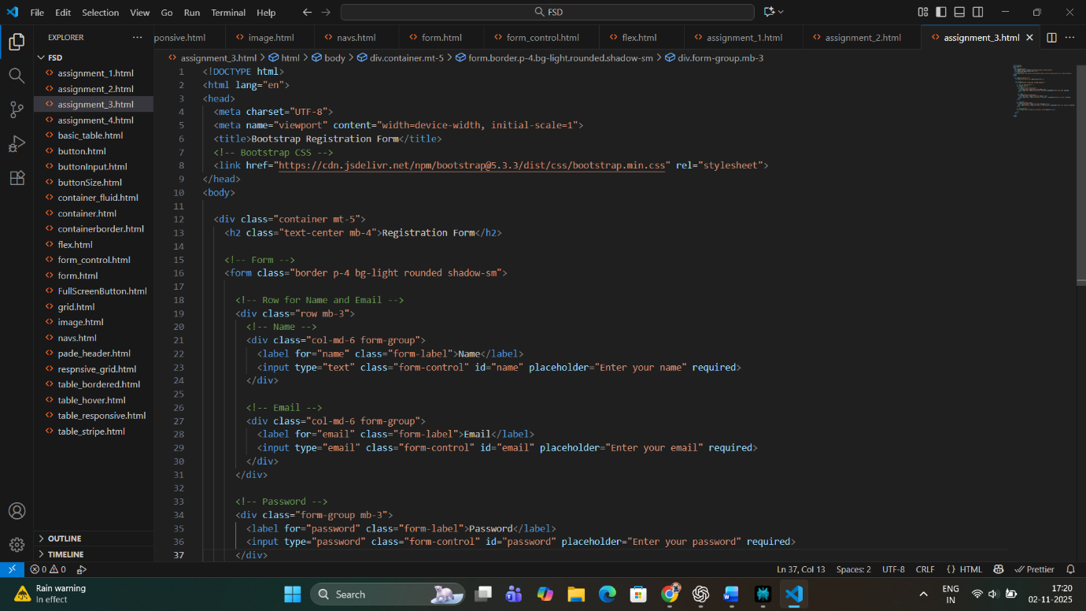

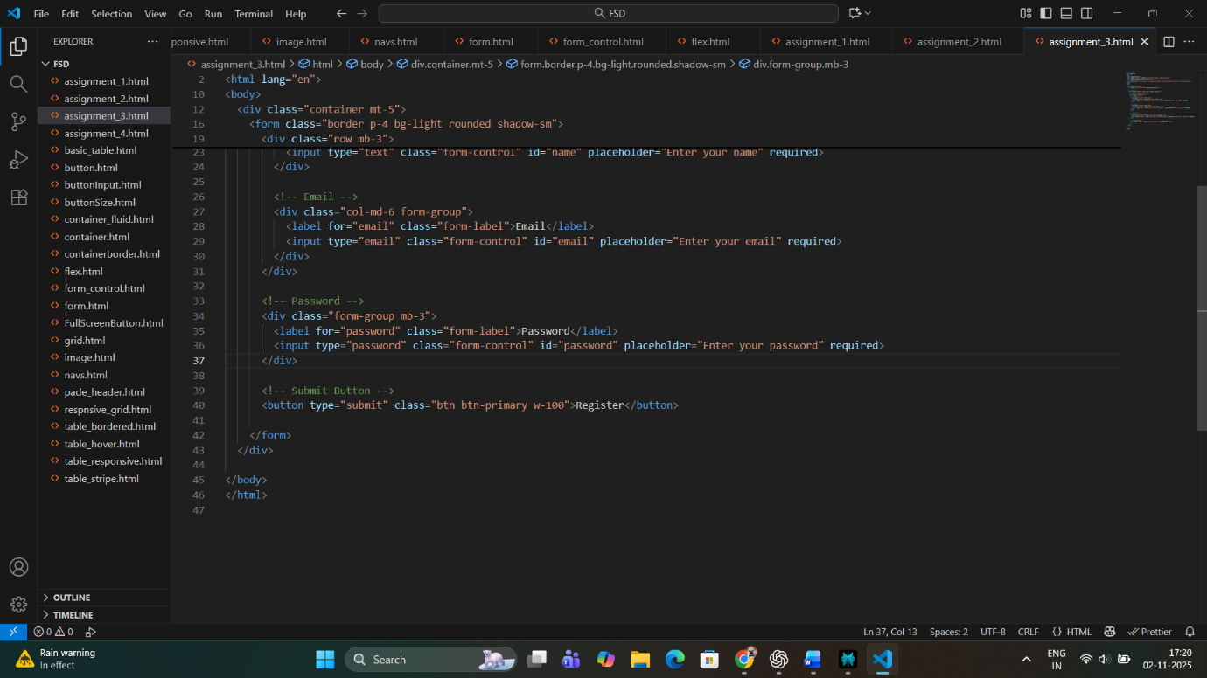

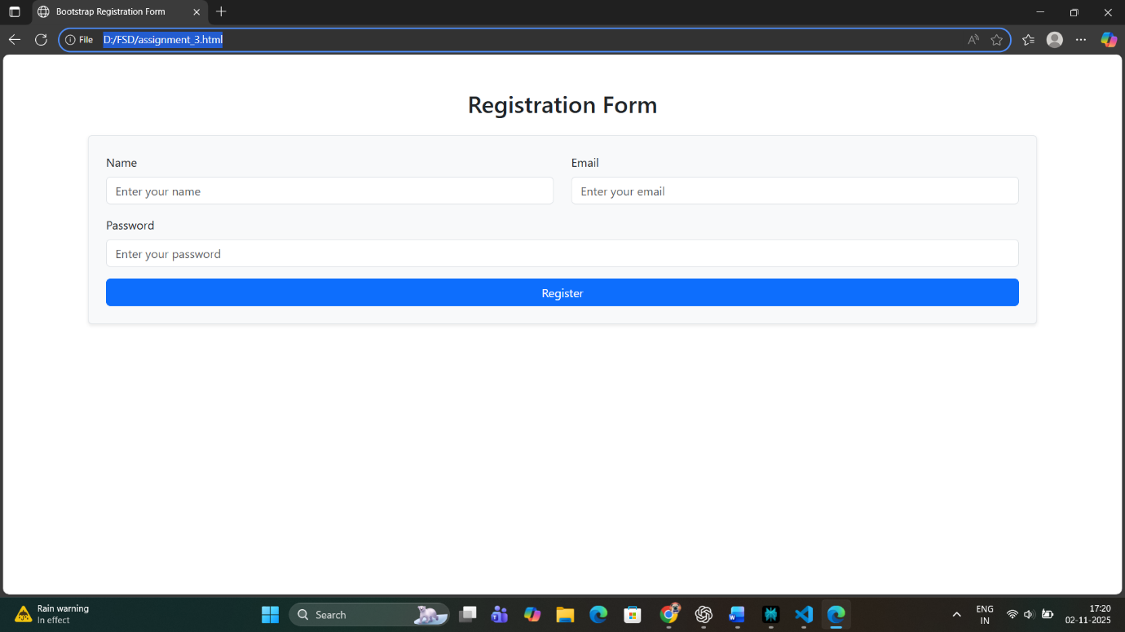

**Conclusion:**

In this assignment, we integrated **Bootstrap forms and tables** into our Medicine Management System.  
The forms enhance user interaction during checkout and profile updates, while the tables provide an organized way to display cart and order information.  
This integration not only improves visual appeal but also ensures **responsiveness, accessibility, and usability** across devices.  
Such structured data presentation creates a professional and trustworthy user experience — essential for any healthcare-related web application.

**Assignment 4: Responsive Design Using Bootstrap Grid and Utilities**

**Aim:**

To apply Bootstrap’s **Grid System** and **Utility Classes** across all pages of the MediCare+ project to ensure a responsive, structured, and visually consistent design that adapts seamlessly across mobile, tablet, and desktop screens.

**Theory:**

Responsive design is a key principle of modern web development that ensures web pages automatically adjust their layout based on the device’s screen size.  
Bootstrap provides a **12-column grid system** and multiple **utility classes** to help developers achieve a clean, flexible, and responsive layout with minimal CSS code.

**1. Bootstrap Grid System:**

* Based on rows and columns inside a container (.container or .container-fluid).
* Allows developers to divide pages into responsive sections using column breakpoints like:
  + .col- (extra small devices)
  + .col-sm- (small devices)
  + .col-md- (tablets)
  + .col-lg- (desktops)
  + .col-xl- (large screens)
* Automatically stacks columns on smaller devices.

**2. Bootstrap Utility Classes:**

Utility classes allow fast customization without custom CSS.

* **Flex utilities:**
  + .d-flex, .justify-content-center, .align-items-center
  + Used for centering and aligning content horizontally or vertically.
* **Spacing utilities:**
  + m-* for margin, p-* for padding (e.g., p-3, mt-4)
* **Text utilities:**
  + .text-center, .fw-bold, .text-primary
* **Display and visibility:**
  + .d-none, .d-md-block to control element visibility by device type.

These utilities enable you to build consistent, readable, and device-friendly layouts with ease.

By applying these to the MediCare+ project, every page — from Home to Profile — becomes **adaptive and intuitive**, ensuring accessibility for users on any screen.

Utility classes in Bootstrap allow quick styling modifications directly in HTML, reducing dependence on custom CSS. These classes target specific design needs such as alignment, spacing, sizing, visibility, and typography.

**a. Flex Utilities**

Bootstrap integrates Flexbox utilities for element alignment and distribution:

* .d-flex activates a flexible container.
* .justify-content-center horizontally centers child elements.
* .align-items-center vertically centers within parent containers.
* .flex-wrap allows content wrapping across lines.

Using these, developers can center critical page content like form buttons, alerts, or card sets, ensuring that important healthcare interactions such as booking appointments or confirming medication schedules remain accessible and easy to interact with.

**b. Spacing Utilities**

Spacing utilities are used to add margin and padding without custom CSS declarations:

* m-* for margin (e.g., mt-3 for top margin)
* p-* for padding (e.g., p-4 for inner spacing)
* Combined usage (e.g., mx-auto centers items horizontally)

These utilities enhance visual clarity between elements, particularly in information-rich environments like MediCare+, where separating data blocks (e.g., between patient info, medicine lists, and reports) improves readability and user comfort.

**c. Text Utilities**

Typography plays an important role in accessibility:

* .text-center aligns text to the center.
* .fw-bold emphasizes key content (like medication names).
* .text-primary, .text-success, and .text-danger provide consistent color coding aligned with Bootstrap’s predefined theme palette.

MediCare+ uses these utilities to highlight vital notices such as “Active Prescription,” “Dosage Missed,” or “Stock Low,” allowing instant visual recognition.

**d. Display and Visibility Utilities**

Bootstrap visibility controls ensure the interface adapts based on device type:

* .d-none hides elements across all devices.
* .d-md-block shows elements only on medium and larger screens.
* .d-sm-inline-block displays an element selectively on small screens.

For example, detailed charts or tables that are too large for mobile screens can be hidden and replaced with summarized text or icons using these utilities. This helps conserve readability and ensures that no crucial content spills off smaller screens.

Code:

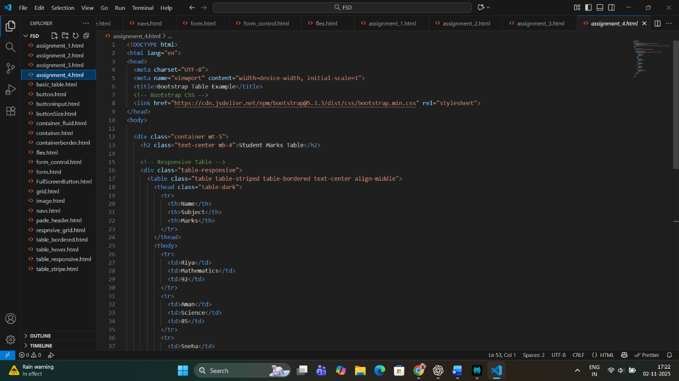

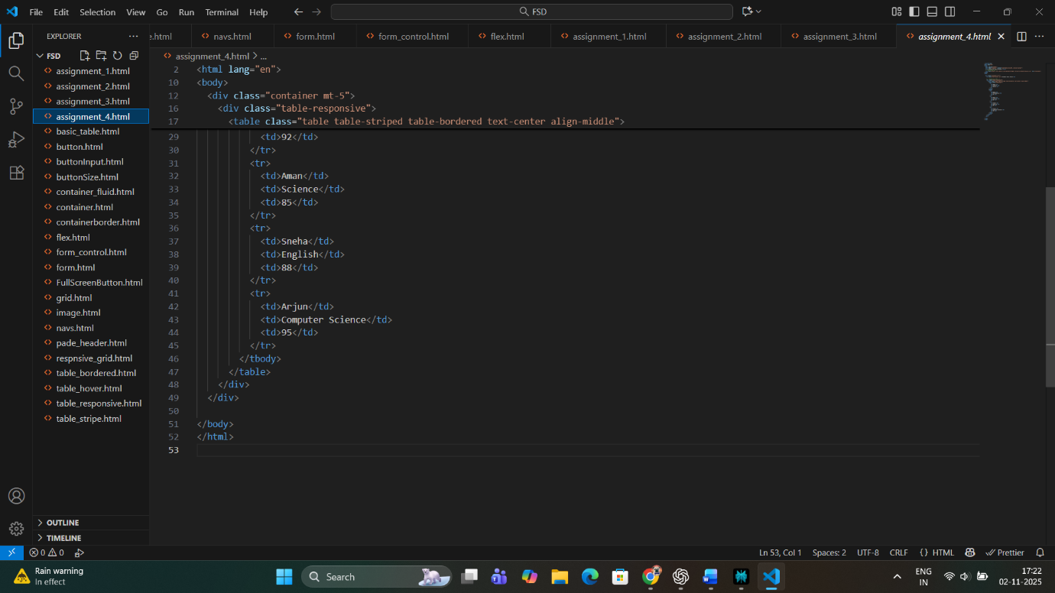

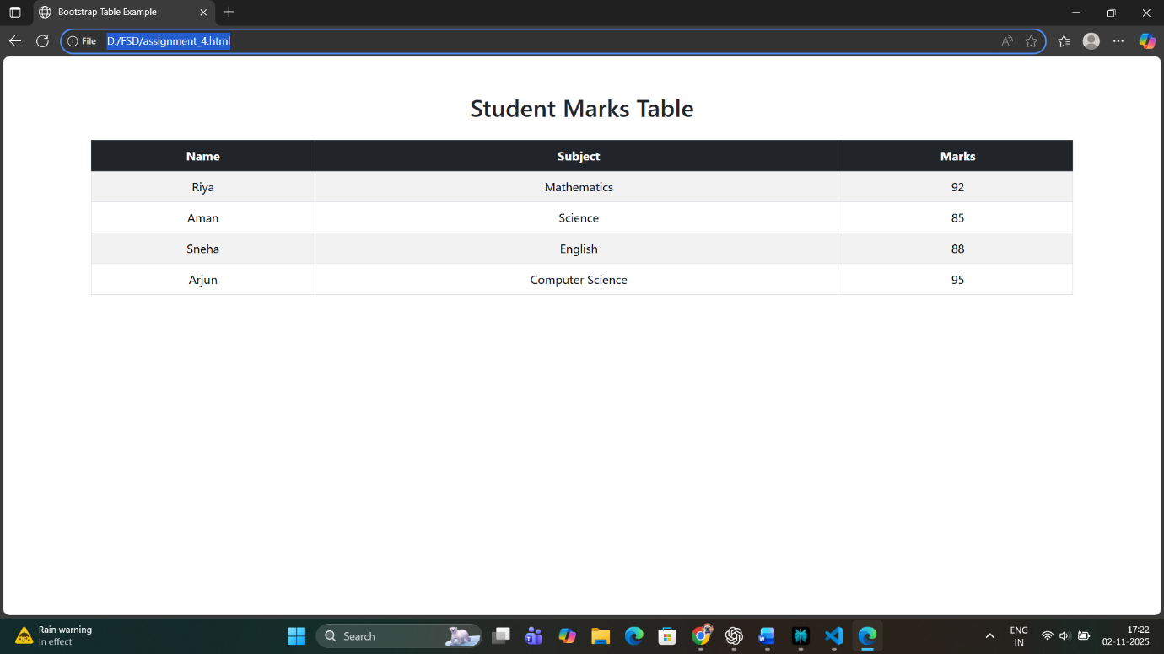

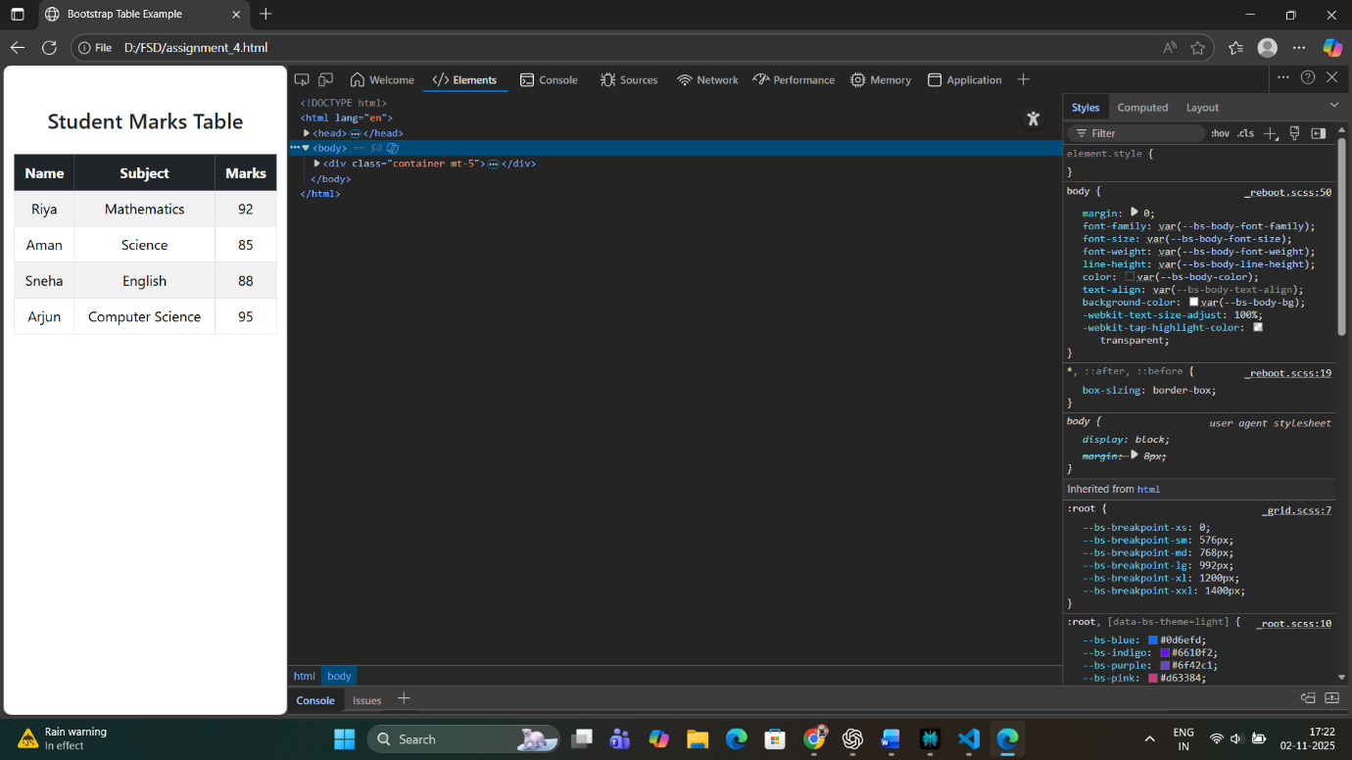

**Conclusion:**

This assignment implemented **Bootstrap’s grid and utility classes** throughout the MediCare+ project, ensuring every page — from Home and Cart to Profile — maintains a uniform, responsive, and professional layout.  
By combining Bootstrap’s responsive grid with spacing, alignment, and visibility utilities, the interface adapts smoothly to various screen sizes, providing users with a **mobile-friendly and accessible experience**.

Through this responsive approach, the website achieves:

* Enhanced usability on all devices,
* Reduced need for custom CSS,
* Faster development and testing cycles, and
* A consistent user interface across all pages.

In conclusion, responsive design ensures that MediCare+ not only looks elegant but also remains functional and accessible, promoting better health management through technology.